Universiti Teknologi MARA

E-Logbook Mobile Application with AI-Assisted Writing and
Reminder System for Internship Students

MUHAMMAD HAZIQ AIMAN BIN BAHARI

Thesis submitted in fulfilment of the requirements for Bachelor of Computer Science (Hons.) Netcentric Computing
Faculty of Computer and Mathematical Sciences

JULY 2026

SUPERVISOR APPROVAL
E-LOGBOOK MOBILE APPLICATION WITH AI-ASSISTED WRITING AND
REMINDER SYSTEM FOR INTERNSHIP STUDENTS

By

MUHAMMAD HAZIQ AIMAN BIN BAHARI
2025119751

This thesis was prepared under the supervision of the project supervisor, Sir Alif Faisal bin Ibrahim. It was submitted to the Faculty of Computer and Mathematical Sciences and was accepted in partial fulfilment of the requirements for the degree of Bachelor of Computer Science (Hons.) Netcentric Computing
Approved by,

…………………………………
Sir Alif Faisal bin Ibrahim
Project Supervisor

JULY 3, 2026

STUDENT DECLARATION
I certify that this thesis and the project to which it refers is the product of my own work and that any idea or quotation from the work of other people, published or otherwise are fully acknowledged in accordance with the standard referring practices of the discipline.

…………………………….
MUHAMMAD HAZIQ AIMAN BIN BAHARI
2025119751

JULY 3, 2026

ACKNOWLEDGMENT
In the name of Allah, the Most Gracious and the Most Merciful. Alhamdulillah, I am sincerely thankful to Allah SWT for His infinite grace, guidance, and blessings, which have bestowed upon me the necessary strength, patience, and determination to accomplish this Final Year Project. No success could be attained in any step taken during this process without His permission and grace. During the duration of this Final Year Project, I have had the benefit of immense encouragement, guidance, and assistance from several people, who have contributed in a very important way towards its successful completion.
At the outset, I would like to convey my sincere gratitude towards my supervisor, Mr. Alif Faisal Bin Ibrahim, for his guidance, valuable inputs, and continuous support during the whole course of this project. His inputs have been of great significance in the successful completion of this research work.
It will be great for me to thank from my heart to my dear parents, Bahari bin Hassan and Hamidah binti Hashim, who have loved me unconditionally, prayed for me, sacrificed for me, and always encouraged me throughout my academic life. The faith they have in me and the consistent support they give me are my biggest motivation and source of strength.
Thank you also to all lecturers from the Faculty of Computer and Mathematical Sciences for their guidance, knowledge, and support throughout my time as a student here. The knowledge and experiences I acquired in my academic pursuits have been invaluable in both my personal and professional growth.
I would also like to thank all my friends, particularly my best friends, for the support, understanding, cooperation, and moral strength they provided throughout this journey. The experience, memories, and inspiration gained from all of us made this hard journey both enjoyable and worthwhile. I really appreciate the fact that they were present for me during the good and bad times of this project
May Allah SWT bless all those who have contributed towards my success during this whole process. I am very grateful to each and every person who has helped me in achieving success in this project.

TABLE OF CONTENT
SUPERVISOR APPROVAL i
STUDENT DECLARATION ii
ACKNOWLEDGMENT iii
TABLE OF CONTENT iv
LIST OF FIGURES vii
LIST OF TABLES viii
CHAPTER 1 INTRODUCTION 1
1.1 Background of Study 1
1.2 Problem Statement 2
1.3 Objectives 3
1.4 Project Scope 4
1.5 Project Significance 4
CHAPTER 2 Literature Review 5
2.1 Internship Management and E-Logbook Systems 6
2.1.1 Internship 6
2.1.2 Internship Management 7
2.1.3 Current Issues in Internship Management 8
2.2 Information Systems for Internship Management 9
2.2.1 Internship Management Systems 9
2.2.2 Mobile-Based Internship Systems 10
2.2.3 Cloud-Based Internship Systems 11
2.2.4 Role of Information Systems in Internship Management 11
2.3 Artificial Intelligence and Smart Technologies 13
2.3.1 Artificial Intelligence in Education 13
2.3.2 AI-Assisted Writing 13
2.3.3 Reminder and Notification Systems 14
2.3.4 Image Documentation Support 15
2.4 Development Tools and Technologies 16
2.4.1 Flutter Framework 16
2.4.2 Laravel Framework 17
2.4.3 PostgreSQL Database 17
2.4.4 Gemini API Integration 18
2.4.5 Pusher Channels 18
2.4.6 Firebase Cloud Messaging 19
2.4.7 Cloudinary 19
2.4.8 Laravel Sanctum and Role-Based Access Control 20
2.5 Related Works and Similar Applications 20
2.5.1 A Digital Solution for Student Internship Tracking and Enhancing Student's Experience 20
2.5.2 The Development of an Integrated Cloud-Based System to Enhance Internship Management 21
2.5.3 Mobile-Based Student Internship Monitoring System Using Progress Tracking Algorithm 22
2.5.4 Web-Based Student Internship Monitoring Information System 23
2.5.5 Comparison of Existing Systems 24
CHAPTER 3 METHODOLOGY 28
3.1 Project Framework (Software Development Methodology) 28
3.2 Phase 1: Requirement Analysis 30
3.3 Phase 2: System Design 32
3.3.1 System Flowchart 32
3.3.2 System Architecture 35
3.3.3 Use Case Diagram 37
3.3.4 Entity-Relationship Diagram (ERD) 39
3.3.5 Storyboard and User Interface Design 40
3.4 Phase 3: Implementation 48
3.4.1 Mobile Application Development 48
3.4.2 Web-Based Administrative Dashboard Development 49
3.4.3 Backend API and Database Development 49
3.4.4 Third-Party Service Integration 49
3.4.5 Authentication and Access Control Implementation 50
3.5 Phase 4: Testing 50
3.6 Phase 5: Deployment and Documentation 52
3.7 Summary of the Chapter 53
REFERENCES 54

LIST OF FIGURES
Figure 2.1 Proposed Student Internship Tracking Management System 21
Figure 2.2. Use case diagram of the E-Kehadiran system 22
Figure 2.3. Student Logbook Menu Page 24
Figure 3.1 Waterfall Model Framework 29
Figure 3.2 Requirement Analysis 30
Figure 3.3 System Design Phase 32
Figure 3.4 Student Flowchart 33
Figure 3.5. Admin Flowchart 34
Figure 3.6. Lecturer and Company Supervisor Flowchart 35
Figure 3.7. Three-Layer System Architecture 36
Figure 3.8. System Use Case Diagram 38
Figure 3.9. System ERD 39
Figure 3.10. Login Page 41
Figure 3.11. Student Dashboard 41
Figure 3.12. Logbook List Page 42
Figure 3.13. Create Logbook Entry Page 42
Figure 3.14. AI Writing Assistance Page 43
Figure 3.15. Attachment Upload Page 43
Figure 3.16. Messaging Page 44
Figure 3.17. Notification Page 44
Figure 3.18. Profile Page 45
Figure 3.19. Webpage Login page 45
Figure 3.20. Admin Dashboard 46
Figure 3.21. Admin User Management 46
Figure 3.22. Generate and Download Reports 47
Figure 3.23. Logbook Review 47
Figure 3.24 Implementation Phase 48
Figure 3.25 Testing Phase 50
Figure 3.26 Deployment and Documentation Phase 52

LIST OF TABLES

Table 2.1 Comparison between System 25
Table 2.2 Sumarry Table for reviewed system 27
Table 3.1 Hardware Requirement 32
Table 3.2 Software Requirements 32

INTRODUCTION
This chapter introduces the background of the study, identifies the problem statement, and presents the research objectives, project scope, and significance of the study. It also describes the overall approach to addressing the identified problems and provides an overview of the proposed Internship E-Logbook System. This chapter serves as the foundation for the subsequent chapters of the project.

Background of Study
An internship, industrial training or practical work is crucial when it comes to obtaining higher education, as it allows students to acquire hands-on experience and make use of theoretical knowledge in practical settings. The students are expected to fill their logbooks during their time in practice as a requirement of the program. Such a system allows tracking the progress of the students and evaluating their performance both by academic and company supervisors to enhance the process in general (Wan Abdul Rahman et al., 2024).

Conventional ways of keeping internships' logbooks have certain disadvantages. Namely, students might not keep their books updated due to the lack of motivation. Also, a conventional logbook does not allow real-time supervision, hence, lecturers and company supervisors do not know how well the students are doing and whether there is anything to correct (Dewi & Hanifah, 2024).
In light of the advancements made in the field of mobile technologies and digital platforms, the manual system has become more efficient. The modern systems used in internship management incorporate applications that operate on mobile devices along with algorithms that track progress. In this manner, learners are able to check in and out based on GPS locators. This helps them record time accurately each day (Castro, 2024). Moreover, the introduction of cloud computing in these systems allows for effective handling of large amounts of internship data within university education sectors (Thammastitkul, 2023).
Furthermore, the incorporation of smart digital technology improves the internships carried out by learners through the provision of better tracking and professional development programs. These state-of-the-art systems help connect learners with employers as they develop their skills. They assist learners in improving the quality of their documentation and help teachers manage the process efficiently (Ahmed et al., 2026).
Therefore, this project proposes the development of a mobile-based E-Logbook application integrated with intelligent tracking features. The system will help students keep track of their internship activities through digital logging, submit evidence of work, and get assisted writing tips for improving the quality of entries. Furthermore, there will be reminder notifications to ensure that students do not forget about logging activities. The system also offers interaction capabilities to help students connect with lecturers and supervisors in companies.

Problem Statement
Hence, there arises a need for a better and smarter solution in the form of networks to make the process of recording and monitoring internship activities much better. There have been several changes in the management of internship logbooks from using old-fashioned pen-and-paper based logging systems to using basic digital logbooks. Old ways used to include the manual recording of activities by students on physical logbooks which demanded high levels of discipline and good writing skills. Though the introduction of digital logbooks aimed at increasing convenience, most systems fail to track and monitor effectively (Wan Abdul Rahman et al., 2024).
One of the greatest problems faced when it comes to internship logbook management is the inconsistency of students' entries. Students take too long before updating their logbooks, making the information recorded less accurate. Moreover, manual recording may result in disorganized and non-professional entries. Despite the introduction of basic digital logbooks, they do not motivate students to be consistent in their entries (Dewi & Hanifah, 2024).
Another significant problem is the lack of real-time monitoring and centralized access. In traditional systems, supervisors cannot efficiently track student progress because data is not hosted on a unified platform. Physical logbooks are also vulnerable to loss, while basic digital files lack proper synchronization. This limits the ability of academic and company supervisors to evaluate performance effectively and provide timely feedback (Thammastitkul, 2023). Furthermore, without specific algorithms to monitor progress, the coordination between students and supervisors remains inefficient (Castro, 2024).
Moreover, the current system does not have intelligent support and automation technology. This makes it hard for the students to independently verify the quality of their input, especially for those with little writing skills. In addition, the supervisor will be required to manage huge amounts of student data manually, making it cumbersome and ineffective. Therefore, there is a need to come up with an electronic system that emphasizes the improvement of the student’s experience (Ahmed et al., 2026).
Therefore, there is a need for a more efficient, intelligent and centralized solution to improve internship logbook management. This project proposes the development of a mobile-based E-Logbook application integrated with AI-assisted writing, image-based documentation support and reminder notifications. The proposed system aims to enhance student engagement in reflective writing while supporting lecturers and supervisors in monitoring and evaluating activities through a unified digital platform.

Objectives
To develop a mobile-based E-Logbook application, supported by a web-based administrative dashboard, with AI-assisted writing and reminder features to enhance internship record management.
- To identify the current problems and limitations in manual internship logbook management, including issues related to data recording, monitoring, communication and document submission.
- To develop an AI-powered mobile e-logbook system with automation, access control and collaboration features.
- To test and evaluate the effectiveness of the proposed system in improving logbook management, user experience, monitoring efficiency and overall internship performance tracking

Project Scope
The objective of this study is to build an Internship E-Logbook System which will consist of both mobile application and web-based applications.
In this study, Internship E-Logbook System refers to the entire system, E-Logbook Mobile Application refers to the mobile client part of the system that is built using Flutter, while the web dashboard refers to the web client part of the system that is built using Laravel.
This system will facilitate administrators, lecturers and company supervisors in supervising internship activities. Administrators will manage the users, monitor the system, and generate reports through the analytics dashboard; lecturers will monitor the performance of students and evaluate them; while company supervisors will validate the activities of students and evaluate logbooks and internships.
Students will benefit from the Internship E-Logbook System through simplifying their work of documenting activities during internships. Students can create structured logbook entries, upload supporting documents and receive AI-assisted writing suggestions to improve grammar, clarity and report quality. Reminder notifications are also included to encourage updating of their logbooks.
The system is created as a hybrid platform that utilizes Flutter for the mobile app, while Laravel framework are used for the web dashboard. The backend system is powered by Laravel, while PostgreSQL (hosted on Neon) provides the system with safe data storage. Furthermore, Gemini API is included to offer AI-powered functionalities, including writing recommendations and intelligent feedback generation.

Project Significance
The proposed AI-based system for tracking internships in a logbook would help streamline the internship reporting process, as it would make it easier for students to produce accurate and structured logbooks, overcoming problems like lack of completeness in data input and problems with writing. The suggested system would provide lecturers and company managers with an opportunity to follow the course of the internship, provide feedback, and assess students.
The use of a cloud-based database for storing information would ensure that logbooks would not be lost physically. Moreover, the use of AI-based functions would help students to develop their professional writing skills and save time on creating and monitoring reports, which makes this solution quite productive.
This project benefits the researcher by improving technical knowledge and practical skills in software and mobile application development. Through this project, the researcher gains experience in using technologies such as Flutter, Laravel, PostgreSQL and AI integration. The project also enhances problem-solving, system development and project management skills. Overall, the study contributes to the researcher’s academic development and provides valuable experience for future careers in software and intelligent system development.

Literature Review
In this chapter, the literature review will help in gathering the information and find the suitable solution for the problem that is faced in this project. The analysis to be conducted will provide a lot of information about the domain involved. This information is very helpful to understand the domain being studied in more depth. In addition, appropriate techniques for solving the problems of this project can also be identified from the comparisons that will be made based on several criteria.

Internship Management and E-Logbook Systems

Internship
Internships are learning programs designed in such a way that learners get a chance to gain practical experience in an office or professional environment where they put into practice what they have learned theoretically in school. The internship program is very vital in connecting the institution with the industry because it helps students to understand the real working environment. According to Wan Abdul Rahman et al. (2024), internship programmes enable students to apply classroom knowledge in real working environments, thereby preparing them for future careers and improving their employment readiness. In addition, Bawica (2021) confirms that internship programmes significantly enhance students’ employability readiness by exposing them to real workplace environments and improving their transition from academic to professional settings.
The role of internships is very important in higher education since they offer chances for acquiring competencies that cannot be acquired in the classroom environment alone. Internships allow learners to gain skills, improve their communication skills, and develop problem-solving skills relevant to their fields of study. In addition, internship programs allow universities to evaluate the success of their curriculum by assessing the performance of students in the working environment. Employers also benefit from internships, as such programmes provide companies with competent job applicants and contribute to the development of skilled graduates (Wan Abdul Rahman et al., 2024). Furthermore, Okoye and Edokpolor (2021) emphasise that industrial work experience plays a significant role in developing employability skills such as teamwork, adaptability, and job-related competencies.
In addition to improving employability, internships encourage students to develop professional attitudes, workplace ethics, and teamwork skills (Wan Abdul Rahman et al., 2024). Students are required to complete assigned tasks, communicate with colleagues, and adapt to organisational cultures. According to Bawica (2021), structured internship experiences improve students’ confidence and career readiness, while Okoye and Edokpolor (2021) highlight that experiential learning strengthens the transition from academic environments to the workforce. Therefore, internship programmes are considered an essential component of higher education that supports both academic and professional development.

Internship Management
Internship management refers to the process of planning, organising, monitoring, and evaluating internship activities involving students, academic supervisors, and industry supervisors. Management of internships helps ensure that students are able to achieve the desired learning outcomes, while at the same time allowing supervisors to track their progress. Internship management involves various stages such as internship placement, internship activities management, performance assessment, communication, and document management (Wan Abdul Rahman et al., 2024).
The increasing number of students participating in internship programmes has highlighted the need for efficient internship management practices. There is a need for academic institutions to coordinate many activities such as internship enrolment, supervision allocation, monitoring of interns’ performance, report submission, and evaluation. Without proper management processes, information regarding internship can be dispersed, causing difficulties in performance monitoring and stakeholder coordination (Ahmed et al., 2026). Recent studies also emphasise the importance of digital transformation in internship administration, particularly through integrated cloud-based systems that improve coordination and data accessibility (Wan Abdul Rahman et al., 2024).
According to Wan Abdul Rahman et al. (2024), centralised, cloud-based internship management systems can improve the efficiency of internship administration by consolidating communication, attendance tracking, and logbook documentation into a single platform. Such systems enable students to access internship-related information more easily while allowing supervisors to monitor student progress and provide timely feedback. In addition, Setiaji et al. (2025) highlight that cloud-native internship management platforms further enhance system efficiency by improving integration, scalability, and overall workflow automation through modern system architecture. Therefore, effective internship management plays a crucial role in ensuring a successful internship experience for students and educational institutions.

Current Issues in Internship Management
Management of internships is a very important aspect of tertiary education, although there are many problems which continue to exist, thus making this process ineffective. One of them is the continuous reliance on the old system of logbooks where information about students’ everyday activities during their internships is recorded. Despite the simplicity of this method, these records are easily lost and damaged. According to Ahmed et al. (2026), this method also limits accessibility, making it difficult for supervisors to review students' progress promptly, especially when internships take place far from the institution. Similarly, Seman et al. (2022) highlight that traditional logbook systems often lead to inefficiencies in monitoring student progress and create delays in supervisor evaluation due to lack of real-time access.
In addition to documentation issues, communication gaps between students, academic supervisors, and industry supervisors present another significant challenge. The absence of a centralised platform often results in delayed feedback, lack of coordination, and unclear expectations, particularly when companies do not provide regular updates to the institution (Wan Abdul Rahman et al., 2024). Furthermore, manual record-keeping can lead to incomplete entries, illegible handwriting, and inconsistent reporting, particularly when students delay updating their logbooks. These factors reduce the accuracy and reliability of internship records (Ahmed et al., 2026). Petcharat and Sutthirak (2024) further support that inefficient communication and fragmented systems can significantly affect internship management effectiveness, especially in coordinating stakeholders across different organisations.
In addition, the supervision process itself is fraught with difficulties for administrators who have to assess interns’ performance in writing (Ahmed et al., 2026). Managing paper-based records also reduces the efficiency of data storage and retrieval. Consequently, many educational institutions have adopted digital internship management systems to support real-time monitoring, improve communication, and simplify administrative processes, thereby enhancing the overall effectiveness of internship programmes. Petcharat and Sutthirak (2024) further emphasise that web-based and mobile-enabled internship systems improve supervision efficiency, reduce manual workload, and support better tracking of student performance throughout the internship period.

Information Systems for Internship Management

Internship Management Systems
Internship Management System (IMS) is a type of information system that is developed with the purpose of supporting the management, monitoring, and evaluation of internship programs. It serves as a central portal where internship related information is accessible by both students and academic as well as industrial supervisors, who can also exchange communication through it. The ultimate goal of developing an internship management system is to make the process of internship administration more efficient.
The need for internship management systems has become more crucial as internships become increasingly complex within institutions of higher learning. The conventional methods of administrating these programs involve numerous modes of communications and documentation. As noted by Thammastitkul (2023), the use of a cloud-based internship management system makes the process more effective through the integration of communication, documentation, and monitoring into one system. This leads to the minimization of confusion among students as well as availability of internship related information and resources. Moreover, Ambara et al. (2024) highlight that inefficient documentation and supervision in conventional internship management make the entire process less efficient.
In addition, management systems for internships facilitate better observation of the activities undertaken by students and help give feedback in a timely manner if needed. Centralized internship information makes it easier to make decisions and adds to the process of better organization of internship management. Sidik et al. (2024) point out the importance of real-time monitoring systems that increase the efficiency of supervision and communication between students and their supervisors and decrease delays in performance evaluation and reporting. Thus, the use of IMS is very important for improving internship management.

Mobile-Based Internship Systems
Mobile-based internship systems are applications designed to allow users to manage internship activities through smartphones and tablets. The widespread adoption of mobile devices has encouraged educational institutions to utilize mobile applications as a means of improving accessibility and user convenience. Mobile systems allow students to access internship information, submit reports, record activities, and communicate with supervisors regardless of location.
According to Castro (2024), mobile-based internship systems are accessible anytime and anywhere on Android devices, allowing users to review their progress and related information without dependence on desktop computers or physical paperwork. This flexibility is particularly beneficial for internship students who frequently operate outside university environments, allowing them to document activities immediately after completing assigned tasks. Castro (2024) further developed a mobile-based internship monitoring system that incorporates a GPS locator to verify trainees' presence at their assigned work locations, enabling students to record daily activities and track internship progress through a centralized platform. The study demonstrated that mobile technologies improve monitoring efficiency and simplify internship documentation processes. Therefore, mobile-based internship systems provide significant advantages in terms of accessibility, convenience, and real-time information management.
In addition, Wibowo et al. (2024) highlight that Android-based internship management systems enhance real-time monitoring and supervision by enabling continuous tracking of student activities through mobile platforms. Such systems improve communication between students and supervisors while ensuring that internship documentation is updated efficiently and accurately. Similarly, Kapoh et al. (2024) emphasise that digital internship management systems support real-time monitoring and centralized data management, which significantly improves administrative efficiency and reduces delays in supervision and reporting processes.

Cloud-Based Internship Systems
Cloud computing is a vital part of today’s information systems owing to its capability to provide centralized storage of information as well as remote access to that information. Cloud internship management system utilizes cloud computing technologies for storing and managing information related to internships via servers connected through the Internet.
As Setiaji et al. (2025) indicate, an intern management platform based on cloud technology enables real-time monitoring, automatic registration of attendance, centralized evaluation of performance, and scalability, role-based access control, and security through data encryption. When applied in educational institutions, cloud technologies facilitate the exchange of information between students, lecturers, and administrators and also reduce the need for infrastructure. Furthermore, as indicated by Li et al. (2024), cloud computing facilitates real-time monitoring and centralized processing of data.
Similarly, Thammastitkul (2023) pointed out that technologies of cloud computing enhance the management of internships owing to their capability to provide centralised data storage as well as real-time access to the internships' data. Additionally, cloud computing systems offer automatic backup and synchronisation capabilities that help avoid data loss. Furthermore, Li et al. (2024) state that cloud computing architecture allows for scalable data management as well as multi-device data accessibility, thus making it possible to access and update data on mobile and web platforms.

Role of Information Systems in Internship Management
Information systems have an important part to play in improving the effectiveness of the management of internships. They help with communications, monitoring, documenting, and administration of the process of internship. In a central digital environment, it becomes easy for both students and supervisors to access information related to internship, submit reports, monitor their progress, and communicate with each other effectively. The first of the main contributions of information systems is the improvement in communication between the parties involved. Proper communication will allow students to get continuous guidance during the time of internship.
Moreover, information systems help in internship supervision and evaluation. The supervisors will be able to check the work that students submit, and keep track of the internship progress and possible problems that can arise with greater ease than the manual system. The digital record keeping system makes it easier to manage internships through structured storage of the information. As mentioned by Thammastitkul (2023), central internship management systems provide better coordination and efficiency. Thus, information systems are important tools in modern internship management.
The significant advancement in the field of information systems is the creation of Digital E-Logbook systems that are aimed at replacing the old logbooks made on papers. This application permits the students to record their internships activities electronically using either mobile or internet-based software, thereby ensuring centralized data storage for all internship logs. The usage of digital logs has greatly increased owing to the advancement in mobile technology and cloud computing. In one example, Castro (2024) created a mobile-based internship log that enables students to record their daily activities and monitor their performance easily. Unlike the old manual way, using digital E-Logbook, students can edit their logs anywhere and at any time, whereas the supervisor does not have to collect physical logs.
However, despite all these benefits, there are internship management systems which still use manual or partially digital means, according to earlier research findings (Ahmed et al., 2026; Dewi & Hanifah, 2024). The majority of current systems concentrate mainly on the aspects of activity logging and monitoring. They lack features for improving students’ documentation work quality. These features can include AI writing help, automated reminder notifications, image documentation, intelligent feedback, among others. Moreover, these features are created separately rather than being integrated in a single system. It demonstrates a research gap in the development of the internship management system with digital logbook features along with other useful capabilities. That is why the E-Logbook Mobile Application will be developed to fill the research gap.

Artificial Intelligence and Smart Technologies

Artificial Intelligence in Education
Artificial Intelligence is defined as computer systems that are able to perform activities that need human intelligence in order for them to be performed. Such activities include learning, reasoning, problem solving, decision making, and language understanding. AI technologies have received much attention in many areas including the education sector.
In educational settings, AI systems are employed to enhance learning processes, tailor learning content, and help with academic endeavors. AI systems can help students by giving suggestions, creating learning materials, and providing feedback in response to user input. According to Lang et al. (2024), due to the development of large language models, modern AI systems have been able to provide much more sophisticated features including content creation, writing assistance, and communication in natural language. Likewise, Mah and Groß (2024) stated that the use of AI in higher education has made teaching and learning more efficient through educational productivity enhancement, faculty support, and intelligent technologies integration at universities. Moreover, Peláez-Sánchez et al. (2024) stated that large language models had become an integral part of Education 4.0 because of the ability of AI to help with learning, creation of academic content, and intelligent communication.
The adoption of AI technology in educational systems presents possibilities of making education more productive and less of a burden administratively. With the continued use of technological innovations in education, AI has become one of the major elements in the construction of intelligent information systems

AI-Assisted Writing
AI-assisted writing involves the application of artificial intelligence technologies to enable the users to produce, enhance, and refine their texts. These tools make use of natural language processing and machine learning methods in analyzing the text and making suggestions on issues such as grammar, spellings, sentence construction, readability, and structuring of text.
Good writing ability is one of the factors that are critical for documenting internships as interns are expected to write about their activities and experiences. Not all the students have good writing abilities, and that could affect how they document their internships. One of the benefits of using AI writing assistant tools is that the students get assistance and automated suggestions while they are doing their writing. Mah and Groß (2024) indicated that AI-based technologies are becoming popular in academic work in institutions of higher education, including writing, feedback and content creation.
According to Lang et al. (2024), large language models like Gemini and GPT-4 have the potential of supporting users in producing better-written materials. They can facilitate students in crafting better logbooks with improved professionalism and structure while minimizing the mistakes made during writing. Moreover, Peláez-Sánchez et al. (2024) mentioned that large language models have greatly supported academic writing through helping users in creating content, generating ideas, polishing languages, and encouraging interactive learning. AI writing assistance tools can be productive by saving time spent on documentation.
The integration of AI-assisted writing into internship management systems can therefore enhance the quality of student reports while supporting learning and professional development throughout the internship period.

Reminder and Notification Systems
Systems of reminders and notifications have been incorporated into various applications for their effective usage in improving user engagement and accomplishing tasks and providing information. These systems offer reminders and notifications related to important events, due dates, updates, and incomplete tasks. The use of timely reminders encourages users to accomplish their duties.
Educational settings benefit from reminders since they facilitate learners to control their academic undertakings like submitting assignments, monitoring attendance, and writing reports. Reminders may be provided via mobile apps, emails, or system notifications to make sure that the users are aware of any action that needs to be taken by them. Mustapa and Mustapa (2023) noted that mobile academic reminder applications are beneficial to the users in managing their important deadlines and academic obligations.
In the case of internship management, there is an opportunity to use reminders for students to have consistent entries in their logbooks during the whole internship period. Instead of solely relying on their self-motivation, students will be receiving automated reminders which will prompt them to enter their activities and provide necessary documentation. As a result, there is less probability of incomplete entries and better accuracy of internship documentation. In addition, according to Osowski et al. (2023), personal reminders have been shown to positively influence the user’s timeliness of task completion.
Effective reminder systems contribute to better time management, increased user participation, and improved consistency in task completion. Therefore, notification technologies are valuable components in modern internship management platforms.

Image Documentation Support
Image Documentation is defined as the use of images or visuals to back up information recorded and activities carried out. There is an increasing trend of using digital systems to facilitate the uploading of images for the sake of improving record keeping and providing supporting proof. Images could capture actions taken in the workplace, achievements accomplished, projects undertaken, and other internship experiences.
In internship management systems, image documentation acts as a proof of the activities done by students. The supervisors may be able to view the images and gain insight into the activities carried out by the students. This ensures that the documentation is more reliable.
In addition, image-based documentation helps in fostering reflective learning because it allows the learners to document their experiences and accomplishments during the internship period using visuals. By having written information combined with images, the internship documentation becomes complete and effective. According to Weber et al. (2023), ePortfolio-based internship system helps in documenting the learners' experience by allowing them to submit multimedia documents, including images for reflection and evidence of the learning experiences in order to enhance the assessment process. Furthermore, according to Hartono (2024), web-based internship system improves the quality of documentation by recording daily activity and attaching evidence such as images.

Development Tools and Technologies

Flutter Framework
Flutter is a multiplatform mobile application development framework developed by Google, which allows developers to develop Android and iOS apps using the same code base. This framework contains a wide range of widgets, the concept of declarative user interface (UI), and the hot reload functionality that helps in developing mobile applications quickly and easily. Flutter has gained widespread acceptance in mobile application development because of its versatility, efficiency, and vibrant open-source community, and it allows development of native mobile, web, and desktop apps from a single code base (Kishore et al., 2022).
In Sharma et al. (2022), the authors explore hybrid development strategies in Flutter, paying attention to the widget system provided by Flutter and supporting the mixing of platform-native code with UI built with Dart. An analysis of Flutter's widget system, which is the basis for the declarative UI approach, helps understand why it is possible to support hot reloading and fast iterations without excluding the possibility of implementing platform-specific features using native modules. It can be especially valuable when speaking about the relevance of using Flutter in cases where developers will have to iterate over the UI more than implement the native part.
While Flutter provides built-in native integration for both Android and iOS platforms, this project focuses on Android as the target deployment platform owing to the limitation in the current development environment wherein the build process on iOS requires the use of macOS and Xcode, both of which are not available in the current Windows-based development environment.

Laravel Framework
Laravel is a web application development framework that is written in PHP language and implements the Model View Controller architectural paradigm. It consists of multiple built-in functionalities such as routing, authentication middleware, database support using Eloquent ORM, job scheduling, and broadcasting which enables real-time event communication. All of these built-in functionalities contribute to making development of applications easier and more efficient. In this project, Laravel is the main backend API server where the REST APIs that will be called by both Flutter app and web admin panel are hosted. Laravel framework is widely used for developing web-based information systems due to its structured development environment and various functionalities (Surahmat & Darmawan, 2024).
Recent literature has provided more proof on the appropriateness of Laravel as a framework for developing current-day web applications. According to Qabajeh et al. (2025), the architecture of Laravel follows the MVC pattern which means that the logic, interface, and data of the application are divided into separate entities, hence ensuring better organisation of the code and its scalability. Additionally, Qabajeh et al. noted that Laravel supports authentication, integration with databases, and RESTful APIs development and thus makes communication between front-end and back-end applications safe.

PostgreSQL Database
RDBMS is still an integral part of any modern information system because of the structured data storage, data integrity, and efficient query processing features. As it is possible to organize data in related tables in RDBMS, such a system provides the possibility to efficiently manage complex information and maintains data consistency. Haw et al. (2022) noted that relational databases are still able to ensure reliable performance for data-intensive applications. According to Akhtar (2023), PostgreSQL is consistently ranked among the most popular database management systems worldwide, reflecting its growing adoption among developers for building scalable and reliable applications.
Among the different RDBMS, PostgreSQL is one of the most widely used open-source databases because of its high reliability and good performance, as well as the ability to manage large volumes of structured data. With its help, it becomes possible to store, organize, update, and retrieve data from it. Joiner et al. (2022) found out that PostgreSQL can be efficiently used in cloud-based solutions and perform well when it comes to transaction processing and data analysis. In this project, PostgreSQL is installed in the cloud on the platform called Neon. It means that PostgreSQL in this case works in the serverless environment with the dedicated cloud database having auto-scaling and auto-pause during the downtime.

Gemini API Integration
Gemini API is an artificial intelligence service provided by Google which is built upon large language models (LLMs) capable of creating text, offering context-aware writing suggestions, and helping users write structured content. According to Lang et al. (2024), large language models such as the Gemini family, including Gemini 1.5 Flash, are aimed at facilitating efficient language generation for various practical purposes. In this project, access to Gemini 1.5 Flash model is achieved with the help of Google AI Studio with the usage of a free-tier API key while all API requests are performed server-side in the Laravel backend controller to avoid exposing API key to client application. Integration of the system allows users to generate their logbook text with the help of AI, which means that the application will offer them writing suggestions, grammatical corrections, and structure improvement of their text.

Pusher Channels
Pusher Channels is a hosted real-time messaging service that facilitates two-way communication between the server and client applications via WebSocket connections. In the current project, Pusher Channels are used to facilitate real-time two-way communication between the students, lecturers, and company supervisors in the Laravel backend. Messages can be sent and displayed instantly in the application without the need for page refresh or reloading. Real-time communication systems based on WebSocket technology enhance responsiveness and user experience by facilitating instant exchange of data between clients and the server. With 200 simultaneous connections and 200,000 messages a day, the free plan offers more than enough for the needs of this academic project.

Firebase Cloud Messaging
Firebase Cloud Messaging (FCM) is a cross-platform push notification system created by Google, which, as of the date of writing, provides a service of delivering notifications from server-side apps to mobile devices without any costs and with no published limitation on usage. Firebase Cloud Messaging is a messaging service that provides a persistent connection between Google's servers and registered devices, thereby allowing receiving of notifications even when the targeted application is not working in foreground mode. In the current project, FCM is employed for sending of push notifications to students and supervisors for certain system events such as chat messages, logbook submissions, and feedback notifications. The payload of push notifications is being sent via the HTTP v1 API of FCM, while mobile application receives notifications through Firebase messaging services. Firebase Cloud Messaging has become very popular thanks to high scalability and reliability of message delivery for Android and iOS platforms without any requirements for infrastructure maintenance. Currently, in the free plan of FCM there is no any published limitation on the number of notifications and devices used; therefore, FCM can be regarded as an effective solution for push notifications for mobile apps.

Cloudinary
Cloudinary is a cloud-based solution that allows uploading, storing, delivering (via content delivery network (CDN)), and processing media files including images. Cloudinary is a media-management platform that can make the process of managing the media on web and mobile apps easier. In this project, Cloudinary is employed for the purpose of storing images that were uploaded by students using the mobile application. Laravel is used in order to upload files through the cloudinary-laravel SDK that can integrate into the Laravel filesystem abstraction and return CDN-backed URL in case the upload has been successfully completed. This URL is used by the mobile application in order to show the images more efficiently without saving the binary content in the main database. At the moment of writing, free tier offered by Cloudinary allows one to have up to 25 GB monthly of storage, bandwidth and processing, plus some URL-based transforms including resizing and compression, which can save the data volume consumed by mobile users. Please note that the numbers of the resources offered within the free tier may vary according to the provider's decision.

Laravel Sanctum and Role-Based Access Control
Sanctum is an out-of-the-box Laravel package that offers token-based authentication to mobile applications. The Sanctum system allows for each user to create their own API tokens to gain access to restricted routes. Following the success of the login attempt, the personal access token is generated by the Laravel backend and stored on the client's mobile device to be included as a Bearer token in all further API requests through the Authorization header of the HTTP request (Pari-Ayala & Ramos, 2025).
Role-based access control is implemented via the Spatie Laravel Permission package and enables the establishment of different user roles such as Student, Lecturer, Company Supervisor, and Administrator at the middleware, route, and controller levels. Using this approach allows for creating a robust structure for defining structural access boundaries through specific authorization and isolation workflow (Purba, 2026). This approach guarantees that only certain roles have access to certain system capabilities and data.
The Laravel Sanctum was chosen instead of third-party authentication providers since the package does not introduce any external dependencies, does not involve any additional costs, all credentials are saved in the same PostgreSQL database as the application itself, and is native to Laravel ecosystem.

Related Works and Similar Applications

A Digital Solution for Student Internship Tracking and Enhancing Student's Experience
Ahmed et al. (2026) introduced a model for the digital internships' tracking to facilitate internship management and communication between students and their supervisors. This research was based on certain problems in internship management, including poor communication, difficulties in monitoring the development of students, and absence of any internships' documentation. To solve these problems, Ahmed et al. created the digital platform allowing students to document their internships, submit reports, and communicate with their supervisors through the centralized system.
According to the research findings, the use of the digital system allowed improving internship monitoring, communication, and engagement during internship activities. Thanks to the digitization of internships' documentation, the process of documenting became much easier. Still, the system was created to monitor activities and manage internships, but there were no any intelligent tools such as AI writing, reminder notifications, and other features based on the use of images.
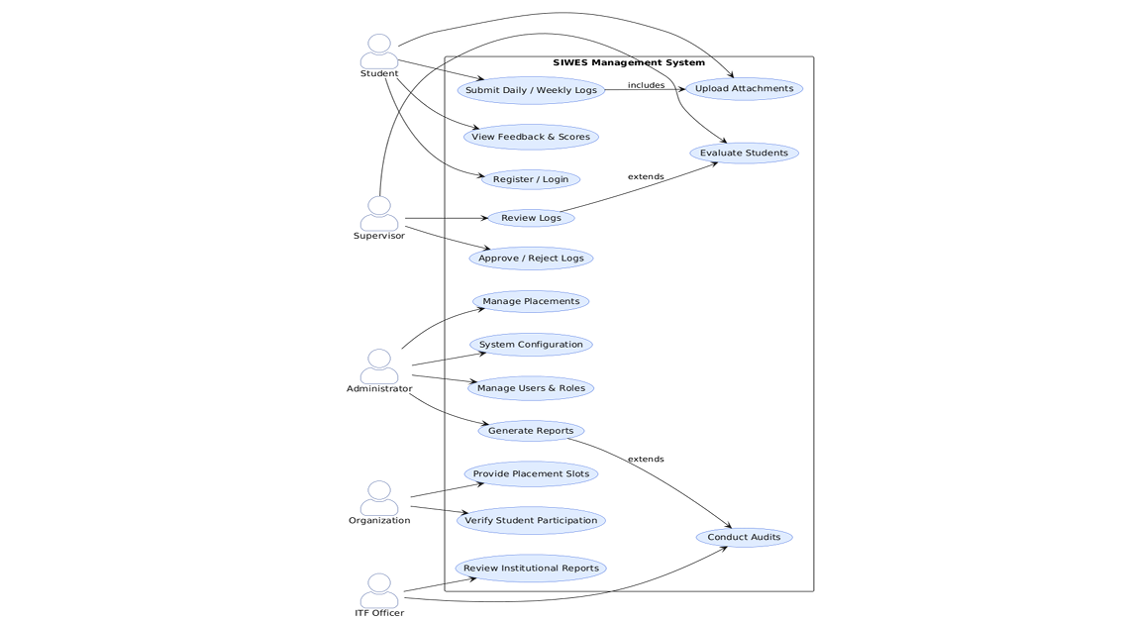
Figure 2.1 Proposed Student Internship Tracking Management System
(Source: Adapted from Ahmed et al. (2026))

The Development of an Integrated Cloud-Based System to Enhance Internship Management
E-Kehadiran is an integrated cloud-based internship management system that was developed by Wan Abdul Rahman et al. (2024). It was created with the goal of improving the process of attendance recording and logbook submission when running internship programs. The research problem for which E-Kehadiran was developed consisted of difficulties in managing attendance, recordkeeping, and communication between universities, internship supervisors, and interns. E-Kehadiran is a web-based system that incorporates such functions as user registration, attendance management, logbook submission, and performance monitoring.
As for implementation results, they were positive and showed that the system managed to increase the efficiency of administrative processes, recordkeeping, and internship monitoring. The user acceptance testing results were also positive and showed that users were satisfied with system integration, usability, and its ability to manage internship processes. However, this system is only aimed at helping with attendance management and logbooks and does not offer any intelligent features such as automated writing with the help of AI or automated feedback. Further development may include using GPS in attendance management and notifications about attendance recording.
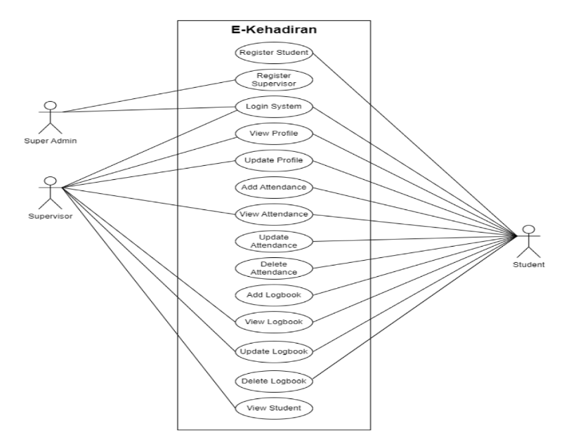
Figure 2.2. Use case diagram of the E-Kehadiran system
(Source: Wan Abdul Rahman et al. (2024))

Mobile-Based Student Internship Monitoring System Using Progress Tracking Algorithm
The researcher Castro (2024) created a Mobile-based Student Internship Monitoring System that incorporates a Progress Tracking Algorithm to enhance the process of managing and monitoring student internships. The research sought to solve problems related to manual internship monitoring, for instance, inaccurate attendance tracking, difficulty in locating student positions, and inefficient record management. The creation of the system involved creating an Android-based system that digitizes the student internship handbook and allows different users, including students, teachers, parents, partners, and administrators, to access and manage information related to internships. To facilitate accurate attendance tracking, the system is equipped with a GPS locator that confirms the positions of the students while clocking-in and out. The process of developing the system involved the use of Throw-Away Prototyping methodology, and UML diagrams were used in designing the system.
Evaluation of the system was carried out using the ISO 25010 software quality model with 30 participants comprising of student interns, teachers, parents, agencies partnering with the school, and IT professionals. Evaluation of the system yielded excellent results for functional suitability, reliability, performance efficiency, usability, security, compatibility, maintainability, and portability, meaning that the system improved internship monitoring and administrative process efficiency significantly. Besides, the system was capable of producing important reports like Daily Time Record (DTR) and task descriptions on a daily basis. Nevertheless, the system did not have any other additional features such as AI logbook writing and documentation. This means that future internship management systems should incorporate artificial intelligence to improve documentation and performance reporting processes.

Web-Based Student Internship Monitoring Information System
A Web-Based Student Internship Monitoring Information System was designed by Dewi and Hanifah (2024) for SMK Ma'arif NU 2 Boyolali, where the problems faced in the manual monitoring process of internships were solved. The previous system utilized journals, attendance lists, daily activity records, submission of final reports, and WhatsApp as the mode of communication. Such inefficiency in managing data and supervision led to the design of the new system, which was built using the SDLC approach and included three user types: administrator, students, and supervisors. In this system, students can take attendance, write their daily logbook, and upload the final report, whereas supervisors can check the same.
The developed system was tested using Black Box Testing and user acceptance tests conducted by the administrator, supervisor, and students. As a result, it turned out that all the system functionalities were performed perfectly, and the overall user satisfaction percentage was 87.53%, which means that the system helped to improve the internship process. Still, the system has not been equipped with any mobile features, real time tracking functionality, cloud integration and intelligent functionalities, such as AI-assisted documentation and analysis. Hence, some of the future improvements of the internship management system can include the integration of the mobile application and artificial intelligence.
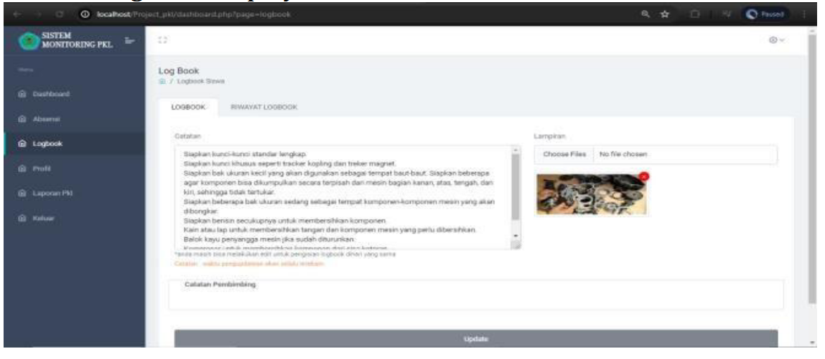
Figure 2.3. Student Logbook Menu Page
(Source: Dewi and Hanifah (2024))

Comparison of Existing Systems
Several internship management systems discussed in Sections 2.5.1 to 2.5.4 demonstrate different approaches to improving internship monitoring, documentation, and communication. While each system offers valuable features, they differ in terms of functionality, accessibility, and level of technological advancement.

Table 2.1 Comparison between System
Features | Ahmed et al. (2026) | Wan Abdul Rahman et al. (2024) | Castro (2024) | Dewi & Hanifah (2024) | Proposed System
Digital Logbook | ✓ | ✓ | ✓ | ✓ | ✓
Mobile Application | ✓ | ✗ | ✓ | ✗ | ✓
Web-Based System | ✓ | ✓ | ✗ | ✓ | ✓
Activity Recording | ✓ | ✓ | ✓ | ✓ | ✓
Real-Time Monitoring | ✓ | ✓ | ✓ | Limited | ✓
Attendance Tracking | Limited | ✓ | ✓ (GPS-based) | ✓ | ✓
Communication Features | ✓ | ✓ | Limited | Limited | ✓
Cloud-Based Storage | ✓ | ✓ | ✓ | Limited | ✓
AI-Assisted Writing | ✗ | ✗ | ✗ | ✗ | ✓
Reminder Notifications | ✗ | ✗ | ✗ | ✗ | ✓
Image Documentation | ✗ | ✗ | ✗ | ✗ | ✓
Intelligent Feedback | ✗ | ✗ | ✗ | ✗ | ✓
All four existing systems provide the core functions of digital logbooks, activity recording, and monitoring, but each has a different focus: Ahmed et al. (2026) and Wan Abdul Rahman et al. (2024) prioritize centralized platforms and communication, Castro (2024) emphasizes mobile and GPS-based tracking, while Dewi and Hanifah (2024) focus on web-based, structured supervision.
None of these systems, however, offer intelligent features such as AI-assisted writing, automated reminders, image documentation, or intelligent feedback. The proposed E-Logbook Mobile Application addresses this gap by combining these intelligent capabilities with the traditional monitoring functions, offering a more comprehensive solution for internship management.
Table 2.2 Sumarry Table for reviewed system
Title | Author, Year | Issues | Methods | Result | Limitation | Future Work
A Digital Solution for Student Internship Tracking and Enhancing Student’s Experience | Ahmed et al., 2026 | Traditional internship management lacks efficient communication, centralized monitoring, and intelligent assistance between students and supervisors. | Developed a digital internship tracking platform with activity recording, report submission, and centralized communication features. | Improved internship monitoring, communication efficiency, and student engagement through a centralized system. | Focused mainly on tracking and management without AI-assisted writing, automation, or advanced intelligent features. | Future research may include AI-assisted writing, automated reminders, and intelligent documentation support.
The Development of an Integrated Cloud-Based System to Enhance Internship Management | Wan Abdul Rahman et al., 2024 | Difficulty in tracking attendance, maintaining accurate records, and ensuring effective communication among stakeholders. | Developed a cloud-based system (E-Kehadiran) with attendance tracking, logbook submission, and centralized monitoring. | Improved administrative efficiency, data accessibility, and communication | Lacked intelligent features such as AI-assisted writing, automated feedback, and smart notification systems. | Future improvements may include GPS-based attendance, notification reminders, and intelligent feedback features.
Mobile-Based Student Internship Monitoring System Using Progress Tracking Algorithm | Castro, 2024 | Existing systems lack accurate attendance tracking, real-time monitoring, and efficient record management. | Developed a mobile-based internship system integrated with GPS tracking and progress tracking algorithms. | Improved attendance accuracy, real-time monitoring, and internship activity tracking efficiency. | Focused mainly on monitoring and tracking without AI-based documentation, analytics dashboards, or writing assistance. | Future work could integrate AI-assisted documentation, analytics dashboards, and enhanced reporting tools.
Web-Based Student Internship Monitoring Information System | Dewi & Hanifah, 2024 | Manual systems using paper-based records and messaging apps cause inefficient monitoring and data management. | Developed a web-based system using SDLC with features such as attendance, logbook submission, and supervisor verification. | Improved internship monitoring, documentation management, and achieved high user satisfaction. | Limited to web platform without mobile access, real-time tracking, cloud integration, or intelligent automation. | Future enhancements may include mobile applications, cloud integration, real-time tracking, and AI-based features.

METHODOLOGY
This chapter describes the structured approach and systematic development lifecycle adopted to design and develop the proposed Internship E-Logbook System. The Waterfall Model has been selected as the software development methodology to achieve the project objectives in an organised and efficient manner. The Waterfall Model follows a sequential, linear approach in which each phase, namely Requirement Analysis, System Design, Implementation, Testing, Deployment and Documentation, must be fully completed before proceeding to the next. This methodology ensures clear documentation, strict control over project requirements, and structured milestones that directly support the development of the mobile application, web dashboard, database and AI-assisted features outlined in Chapters 1 and 2.

Project Framework (Software Development Methodology)
The Waterfall Model will be used as the software development methodology for developing the Internship E-Logbook System because it ensures that every step involved in its software development life cycle is carried out one after the other. The steps are requirement analysis, system design, implementation, testing, and deployment and documentation. This methodology is deemed appropriate for the current project since the requirements of the system in terms of features such as digital logbook entry, AI-powered writing suggestions, notification alerts, and supervision have been determined in the background study and literature reviews carried out in Chapters 1 and 2, hence making the possibility of any drastic changes during the process of development unlikely. Related studies such as Surahmat and Darmawan (2024) and Dewi and Hanifah (2024) who used SDLC methodology together with the Laravel framework to develop web-based information system and web-based internship monitoring system respectively indicated that methodologies like these make the process of development systematic and easily implementable. The Waterfall Model makes it easier for the project supervisor to follow and monitor the development process due to the systematic stages and documentation developed in each stage making it feasible for a single developer FYP project to be developed in a certain period of time in an academic context.
However, despite the fact that several external cloud services the Gemini API, Pusher Channels, Firebase Cloud Messaging, Cloudinary and Neon have been included in the project, whose behaviour and documentation in free tiers cannot be fully managed by the developer, an Agile or Incremental approach will not be applied to this project due to the fact that the connection points with all those external services are specified and well separated into certain modules that will be determined in the Requirement Analysis phase (Section 3.2) AI-Assisted Writing, Real-Time Chat, Notification, and Image Documentation modules instead of being scattered all over the system arbitrarily. Thus, any changes associated with the third-party API behaviour are expected to be restricted to the respective modules and can be implemented in the Implementation and Testing phases without going back to the requirements and system design formulated in the previous phases. However, this approach to building the application is considered as a limitation of applying the Waterfall Model in this case.
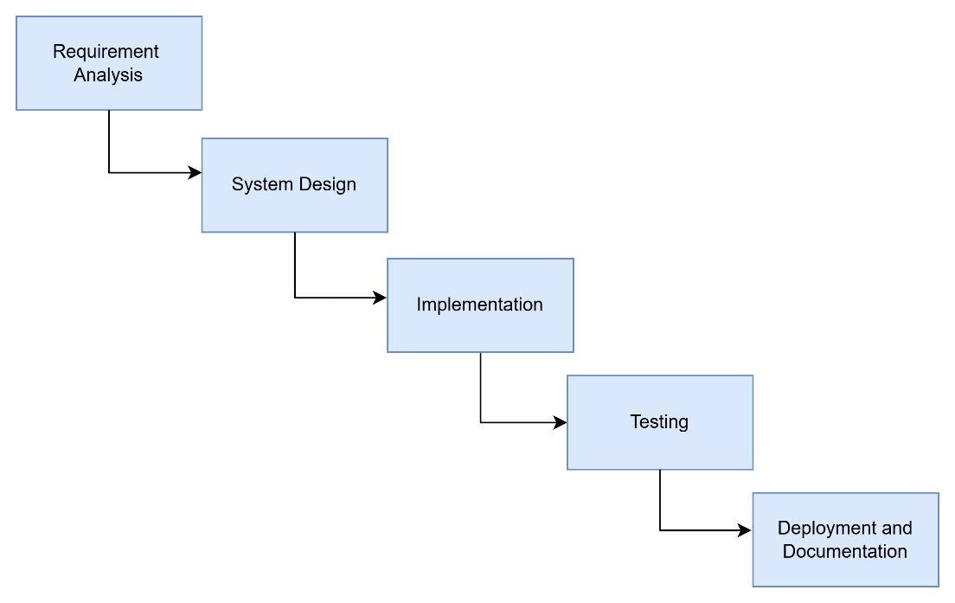
Figure 3.1 Waterfall Model Framework
As illustrated in Figure 3.1, the Waterfall Model adopted for this project consists of six sequential phases: Requirement Analysis, System Design, Implementation, Testing, Deployment and Documentation, with the output of each phase serving as the input to the next.

Phase 1: Requirement Analysis
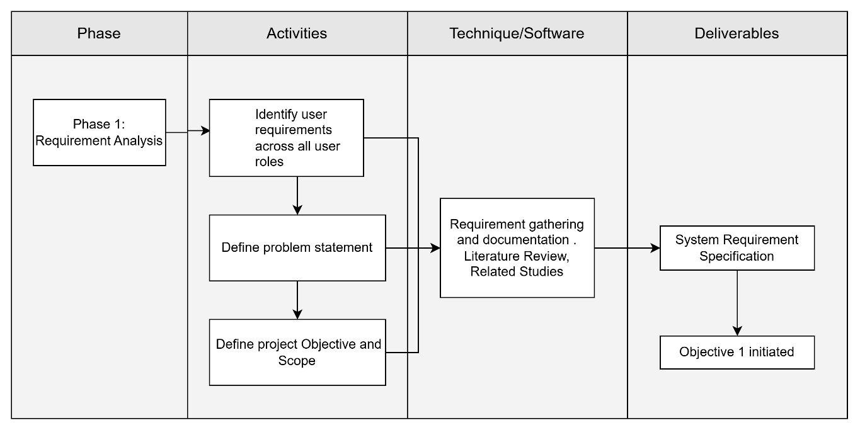
Figure 3.2 Requirement Analysis
As illustrated in Figure 3.2, the Requirement Analysis stage will start with a preliminary analysis in order to create an overview of the problem domain that is to be solved prior to any design and development activities. A preliminary analysis is to be done via background study and literature analysis, which are described in Chapter 1 and Chapter 2, not by means of a survey, interview, or questionnaire because the potential target respondents (the internship students, the lecturers, and the company’s supervisors) are not available for research during the project period of time. Literature analysis of four intern management and monitoring systems (Ahmed et al., 2026; Wan Abdul Rahman et al., 2024; Castro, 2024; Dewi & Hanifah, 2024) reveals some recurrent shortcomings of the systems, such as inability to access the system from mobile devices, no possibility of monitoring process in real time, no help in writing by means of artificial intelligence and automatic reminders, etc. All of these factors and the problem statement in Section 1.2 will be used to derive the system requirements.
The functional requirements of the system that have been recognized include user authentication and role-based access, digital logbook entries generation and submission, AI-powered writing advice, documentation uploading by means of images, live messaging between students and mentors, as well as push notification reminders. The non-functional requirements comprise data security using token authentication, system availability through cloud-hosting, and appropriate response time for live functions such as chat and notifications.
Based on these requirements, the hardware and software needed to develop the prototype will be identified, as summarised in Tables 3.1 and 3.2.

Table 3.1 Hardware Requirement
Hardware | Specification | Purpose
Laptop | Windows 10/11, minimum 8 GB RAM, Intel Core i5 or equivalent | Used for coding, running emulators, and managing the backend server during development
Android smartphone | Android 8.0 or above | Used for testing the Flutter mobile application on a physical device
Internet connection | Minimum 10 Mbps | Required to access cloud-hosted services (Neon, Pusher, Cloudinary, Gemini API, Firebase) during development and testing
Table 3.2 Software Requirements
Software/Tool | Purpose
Flutter SDK and Dart | Development of the cross-platform mobile application
Visual Studio Code | Primary code editor for both the Flutter application and Laravel backend
Laravel Framework (PHP) | Development of the backend RESTful API and web-based administrative dashboard
PostgreSQL (hosted on Neon) | Storage and management of structured application data
Google AI Studio (Gemini 1.5 Flash) | Provision of AI-assisted writing suggestions within the logbook module
Pusher Channels | Real-time chat messaging between students, lecturers, and company supervisors
Firebase Cloud Messaging | Delivery of push notifications for reminders and chat alerts
Cloudinary | Storage and delivery of internship documentation images

Phase 2: System Design
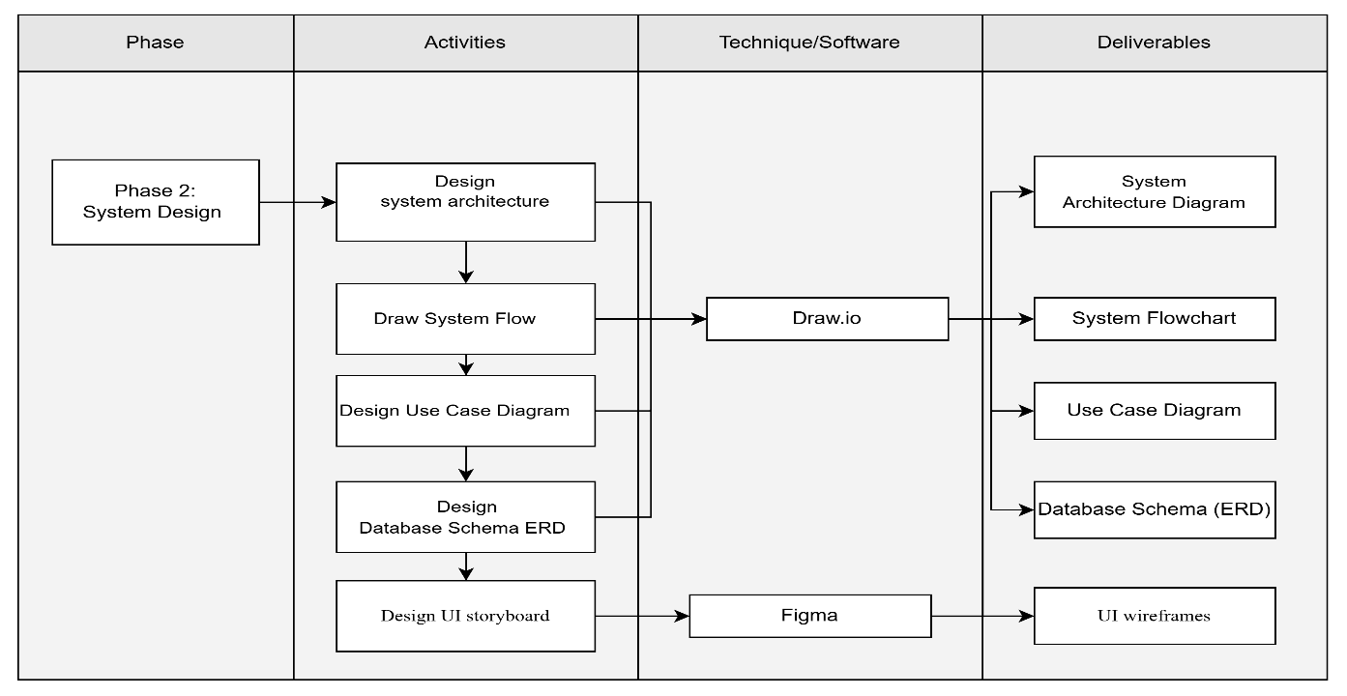
Figure 3.3 System Design Phase
As illustrated in Figure 3.3, The System Design phase will translate the requirements identified in Phase 1 into a structured technical design, covering the overall system architecture, process flow, use case diagram, system architecture, database structure and user interface layout of the proposed system.

System Flowchart
The system flowchart will illustrate the overall process flow of the Internship E-Logbook System, beginning from user login and role verification, followed by role-specific functions such as logbook entry creation, AI-assisted writing, supervisor review, chat communication, and notification delivery.
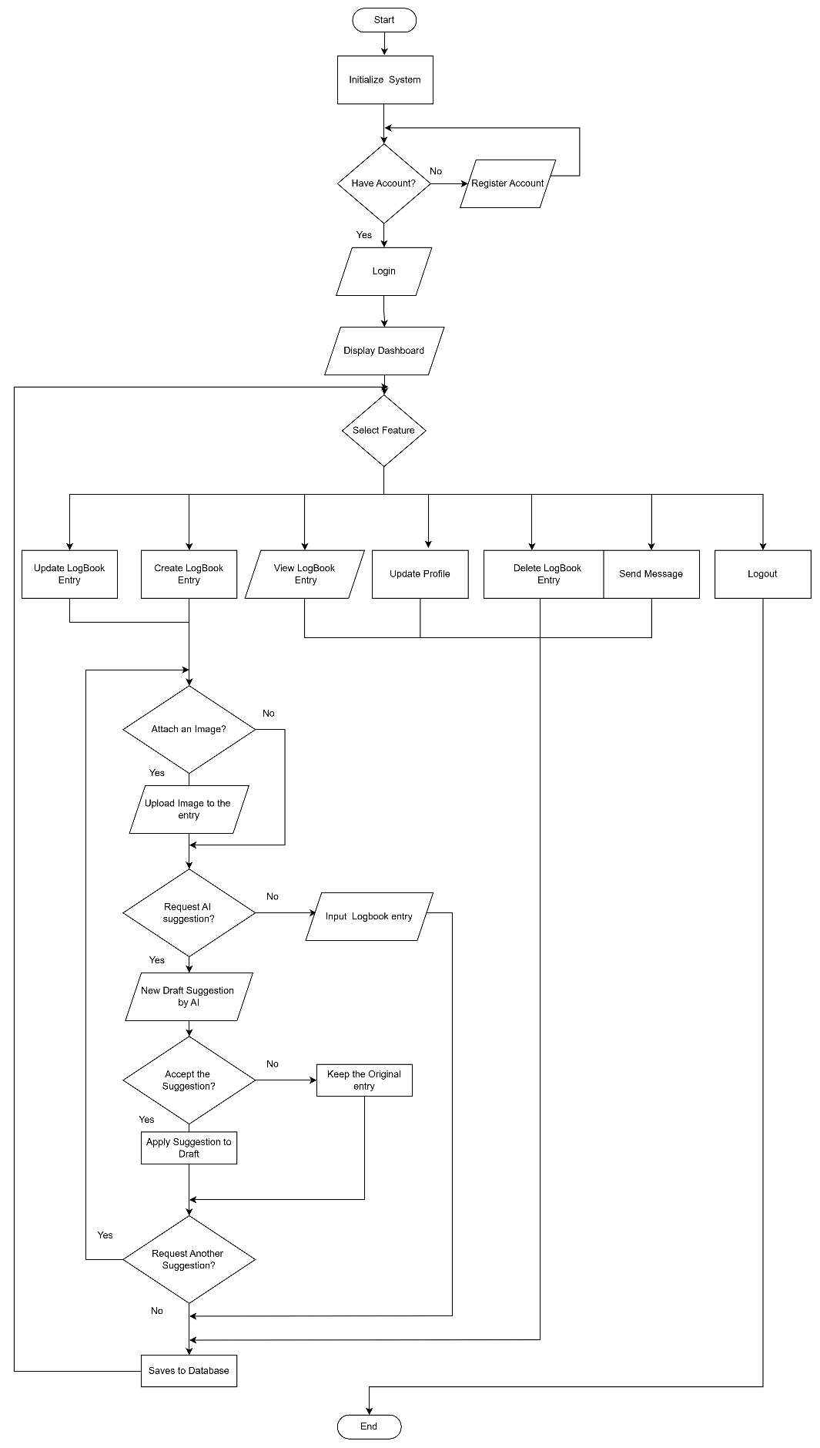
Figure 3.4 Student Flowchart
Figure 3.4 shows the process flow of the E-Logbook Mobile Application, starting from the system initiation and the authentication of users. After initiating the application, the user is redirected to the dashboard page from where he/she can perform multiple tasks like creating, viewing, updating or deleting logbook entry, updating his/her profile, sending messages, and finally logging out of the account. If the user is going to create a logbook entry, then he/she can upload image(s) in support and can seek the help of AI for suggestions regarding writing of content and can either accept or reject the content suggested by AI. Finally, after making an entry, it will be stored in the database.
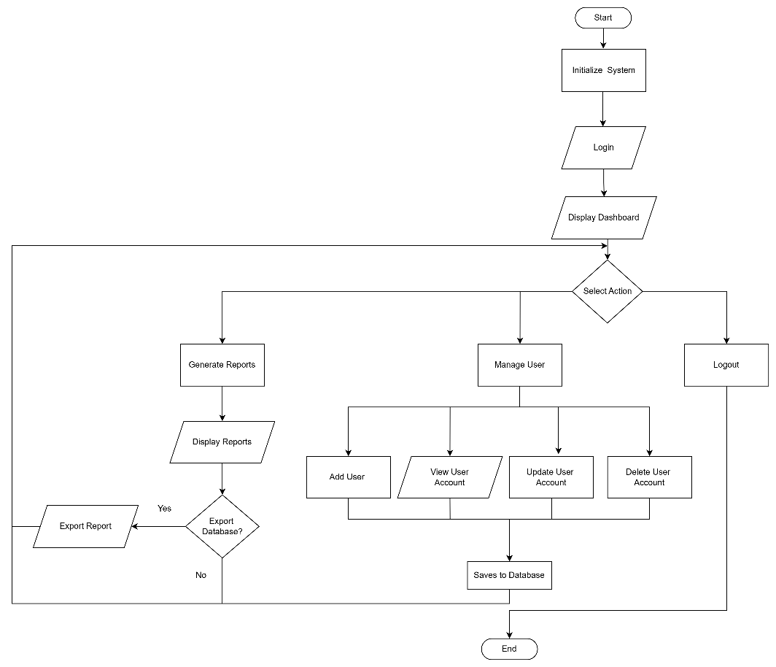
Figure 3.5. Admin Flowchart
Figure 3.5 describes the complete workflow of the user management and report generation system. First of all there is system initialization after which user logins into the system, and the dashboard appears on the screen. User selects an activity after accessing the dashboard, where he/she may manage the users, report generation, or logout from the system. In case of user management module, administrator performs various activities like addition of new users, viewing details of existing users, updating details of existing users, and deletion of users' account in the database. In case of reporting module, the user generates the report and displays it on the screen with the choice of exporting database or reports wherever necessary.
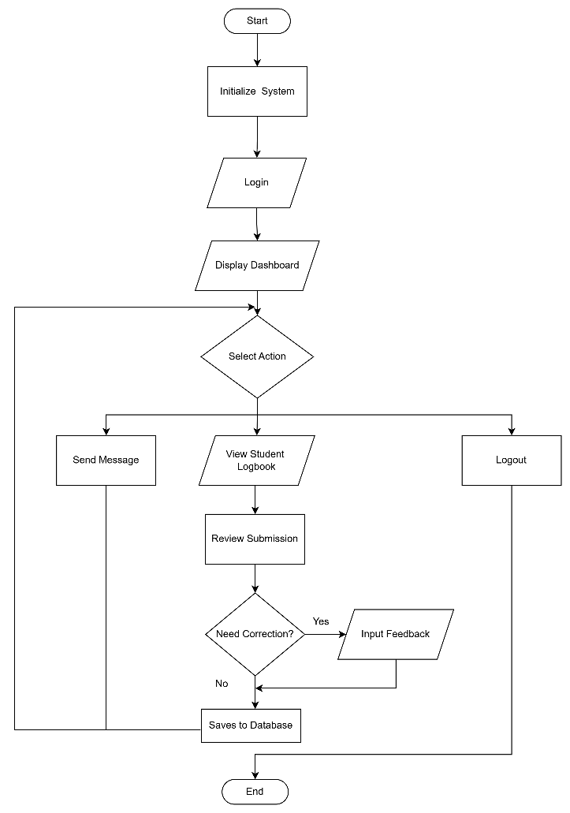
Figure 3.6. Lecturer and Company Supervisor Flowchart
Figure 3.6 shows the working process of the lecturer module of the student logbook management system. The working process starts from system initialization, then there will be a step for user login and dashboard will appear. After dashboard appears, lecturer performs actions such as checking student logbook, sending messages or logout. In the case where lecturer is checking student logbook, lecturer checks the works submitted by students and makes decisions whether corrections have to be made or not. If corrections have to be made, lecturer writes feedback for students' works. All the checks and feedbacks are stored in the database and then the process comes to an end.

System Architecture
Architecture used in the system is that of three-tier approach, including presentation tier, application tier, and data tier along with cloud services for the functioning of the system. As shown in Figure 3.7, the architecture shows how Flutter mobile application and Laravel web dashboard interact with Laravel backend that acts as the core of business logic and data handling processes of the system. In addition to the backend, the system will integrate with different cloud services such as Neon PostgreSQL, Gemini API, Pusher Channels, FCM, and Cloudinary.
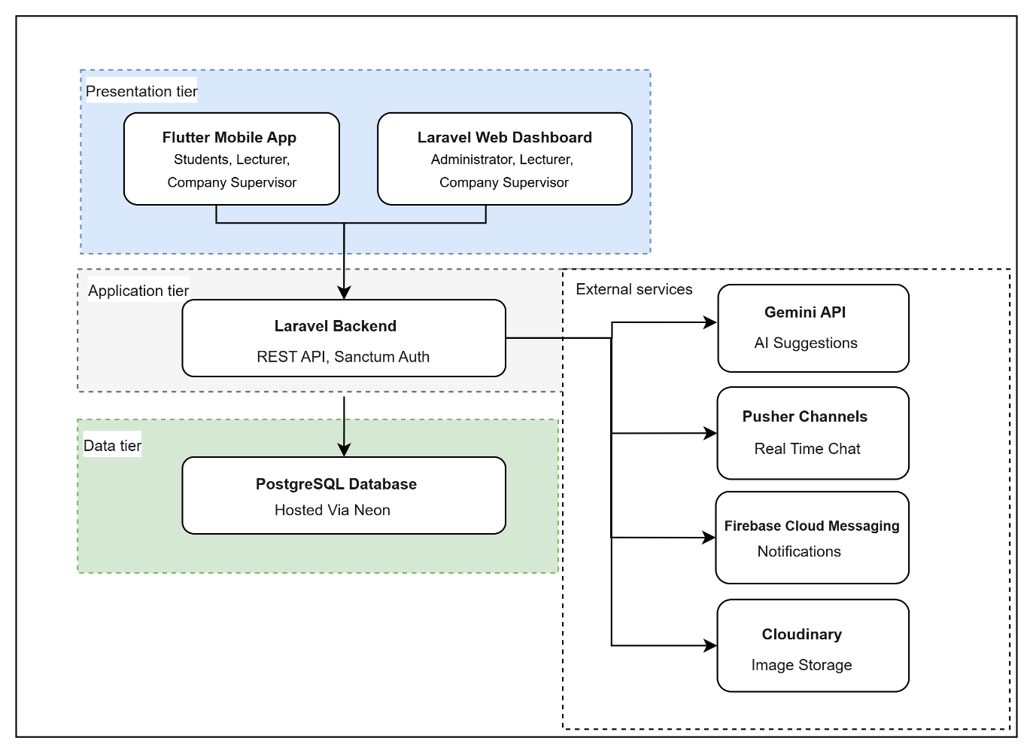
Figure 3.7. Three-Layer System Architecture
The proposed architecture implements a three-tier architecture that involves presentation tier, application tier, and data tier, along with the integration of a number of cloud-based services. In the presentation tier, there is interaction between users and the system via two different interfaces depending on user types. In this case, the mobile application developed in Flutter allows students, lecturers, and company supervisors to use various features related to internships such as submitting reports, tracking progress, communicating, and receiving notifications using mobile devices. Additionally, the Laravel web-based dashboard is available for administrators, lecturers, and company supervisors to perform various tasks in a browser-based manner.
The Laravel backend is the key component in the application layer as it deals with all the requests coming from the client applications. It contains the implementation of the business logic, verifies the data provided by users, takes care of the authentication process via Laravel Sanctum, and communicates with the database and other cloud services. Instead of making the client applications interact directly with the third-party services, all of the requests go through the backend, which gives an extra layer of protection by securing API credentials while keeping everything under one roof. The backend also works together with the Gemini API that provides AI assistance for writing, Pusher Channels that help establish real-time communication, Firebase Cloud Messaging (FCM) that sends push notifications, and Cloudinary for images upload.
The data layer is made up of a PostgreSQL database that is hosted in Neon. The database is used as the primary data storage for everything in the application including users' account details, internships, reports, attendances, chats, notifications and other information. Through the use of a database that is hosted in the cloud, there will be an increase in the scalability, reliability, and maintenance of the system while at the same time keeping data secure and accessible. In general, the layered architecture enables the separation of the user interface, application layer and data layer from each other.

Use Case Diagram
The use case diagram (Figure 3.8) illustrates the functional requirements of the proposed E-Logbook Mobile Application with AI-Assisted Writing and Reminder System by identifying the interactions between the system and its four primary actors: Student, Lecturer, Company Supervisor, and Administrator. Each actor is assigned specific responsibilities and system functionalities according to their respective roles, ensuring that users can only access features relevant to their permissions.
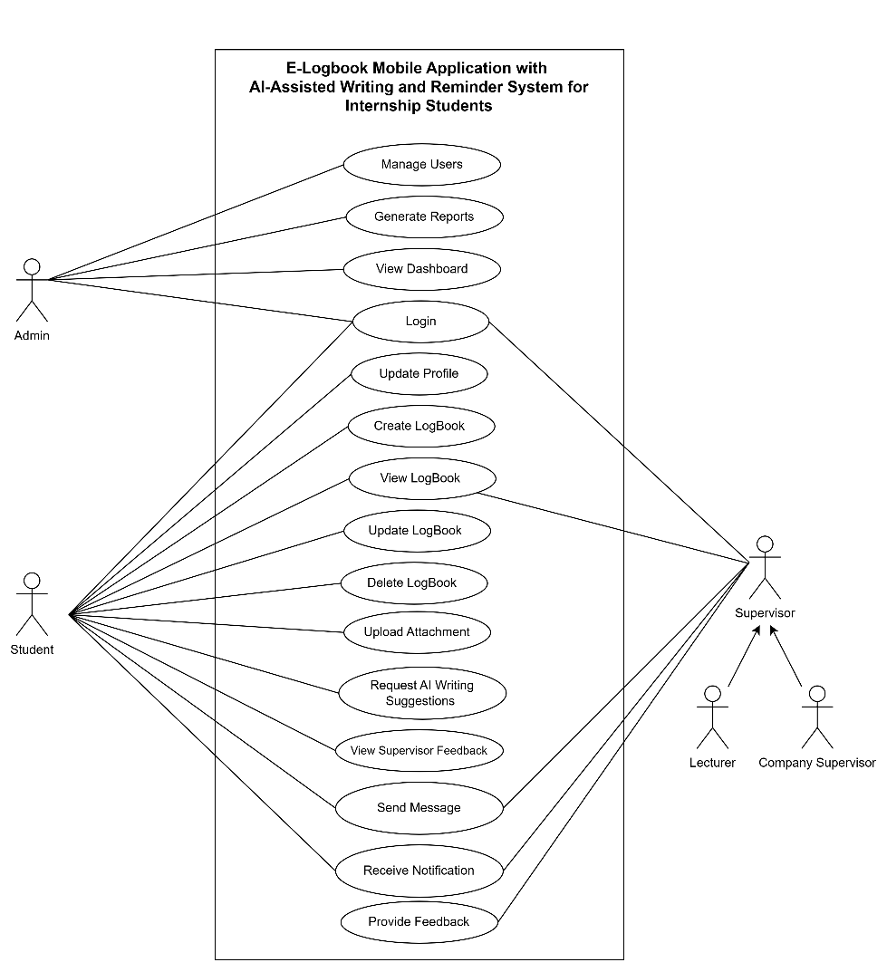
Figure 3.8. System Use Case Diagram
The students are the main users of the system who are able to carry out actions like login, edit profile, create, view, update and delete logbook entries, upload attachments, request AI writing assistance, view supervisor feedback, send messages, and receive notifications. The lecturers and company supervisors are tasked with the role of overseeing the internship process of the students via evaluation of logbooks, giving feedback, interacting with the students using the messaging feature and getting notifications about internship processes. The administrator is tasked with management of user accounts, supervision of the system activities using the dashboard, generation of reports and maintenance of the overall system process.
Generally, the use case diagram helps in illustrating the functional behavior of the system through describing the interactions between the users and the system.

Entity-Relationship Diagram (ERD)
The ERD (Figure 3.9) represents the database structure of the system, showing the key entities and their relationships, including Users, Logbook, Attachment, Message, Notification, and Feedback. Each logbook entry is linked to a single student and may contain multiple attachments and feedback entries, while each user is assigned a role that determines their level of access within the system.
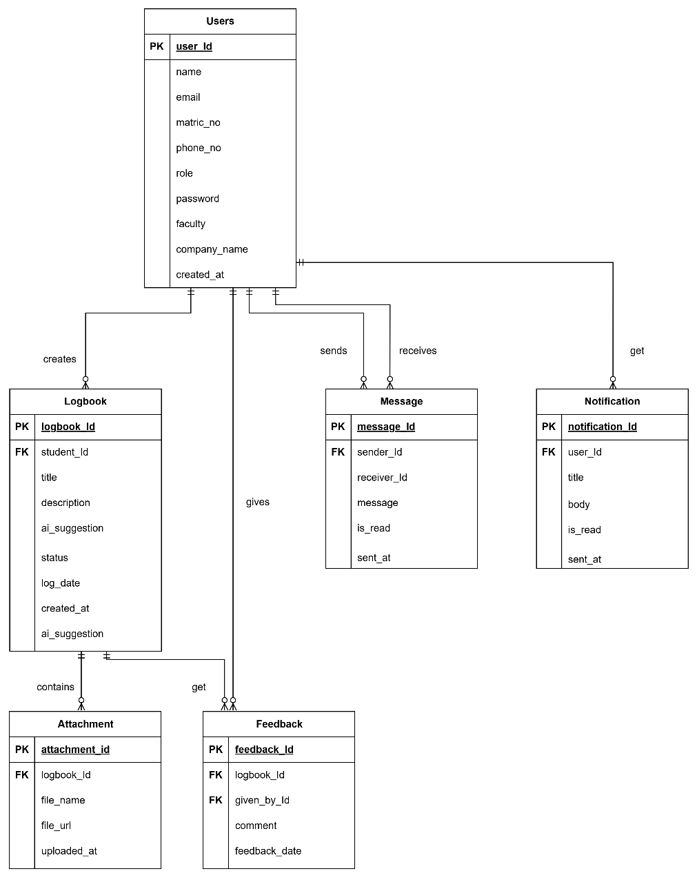
Figure 3.9. System ERD
The entity named Users holds the data for all the system users such as students, lecturers, supervisors from companies, and admins. It stores the profile data, log-in information, and roles of the users.
The Logbook object keeps track of the activities of each student involved in an internship, and also tracks their daily progress during the duration of the internship
The Message object controls communication among students, lecturers, and company supervisors. The message object stores all the chat messages that take place within the system.
The Notification entity holds system notifications generated and sent to the users regarding certain important events, such as new message, feedback, reminder, logbook update, and other activities associated with the internship program.
The Attachment entity is an entity that contains links to files that the students upload as proof of their logbook activity. These attachments could be images, documents, and other files that are linked to the respective logbook record.
The Feedback entity holds the comments or reviews written by the lecturers/supervisors regarding the logbook entry submitted by the students.

Storyboard and User Interface Design
The storyboard illustrates the sequence of screens and user interactions in the proposed system. It outlines the navigation flow to ensure the user interface is intuitive, consistent, and easy to use. It also provides a visual overview of the system's main features and helps verify that users can complete their tasks efficiently throughout the application.
Storyboard | Description
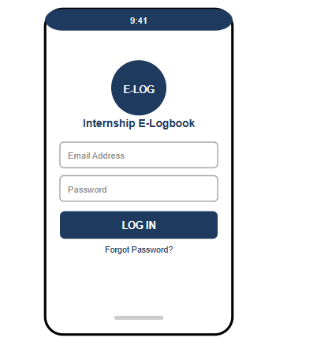  Figure 3.10. Login Page | This page allows users to log in using their registered email address and password. After successful authentication, users are redirected to their respective dashboard based on their assigned role.
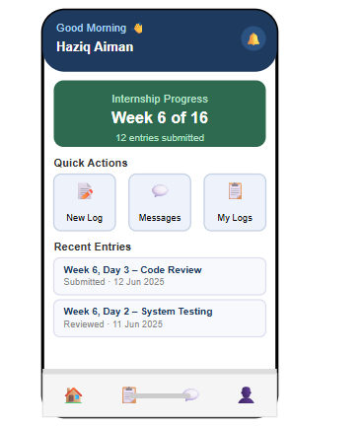  Figure 3.11. Student Dashboard | This page provides students with an overview of their internship progress and quick access to key features such as creating logbook entries, viewing logbooks, and accessing the messaging interface.
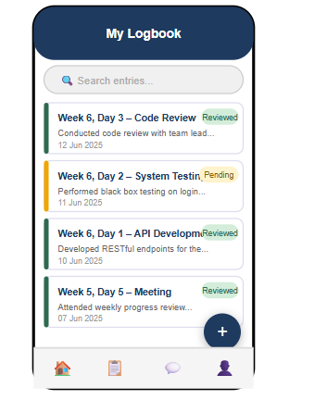  Figure 3.12. Logbook List Page | This page displays all logbook entries submitted by the student. Users can search for specific entries, view their submission status, and create new logbook entries.
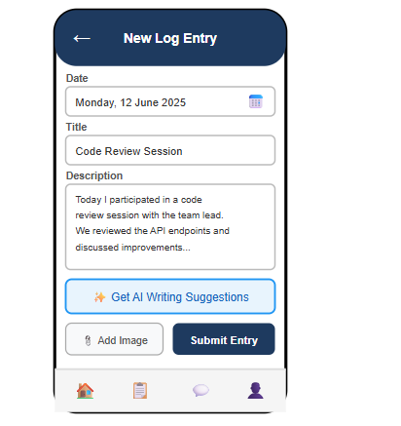  Figure 3.13. Create Logbook Entry Page | This page enables students to create and submit new logbook entries by entering internship activities, attaching supporting images, and requesting AI-assisted writing suggestions before submission.
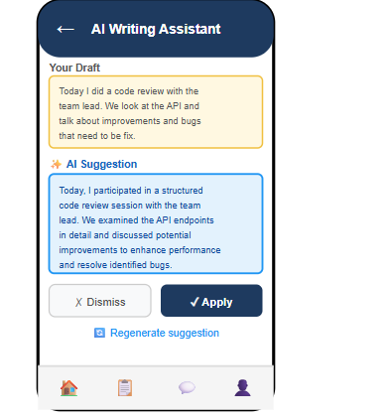  Figure 3.14. AI Writing Assistance Page | This page displays AI-generated writing suggestions to help students improve their logbook content. Students may apply, discard, or regenerate the suggested text.
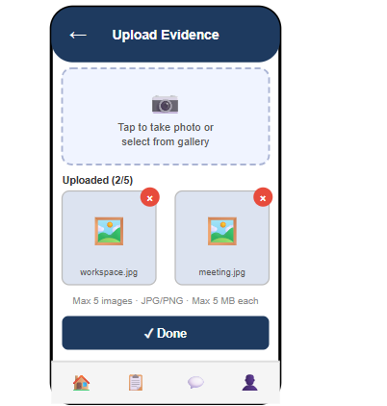  Figure 3.15. Attachment Upload Page | This page allows students to upload supporting images for their logbook entries by capturing a photo or selecting one from the device gallery before submission.
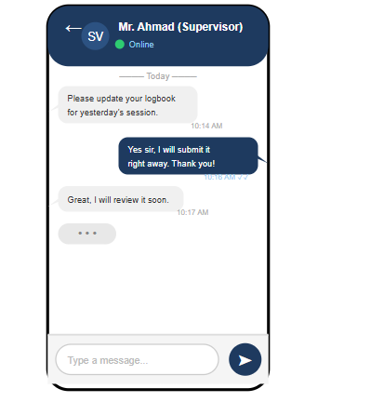  Figure 3.16. Messaging Page | This page enables real-time communication between students, lecturers, and company supervisors, allowing users to exchange messages and receive updates during the internship.
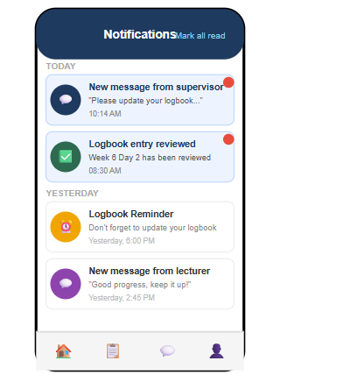  Figure 3.17. Notification Page | This page displays system notifications, including reminders, logbook updates, feedback, and new messages, ensuring users remain informed of important activities.
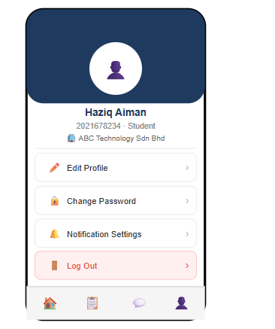  Figure 3.18. Profile Page | This page displays the user's personal information and account settings. Users can update their profile, change their password, manage notification preferences, and log out of the application.

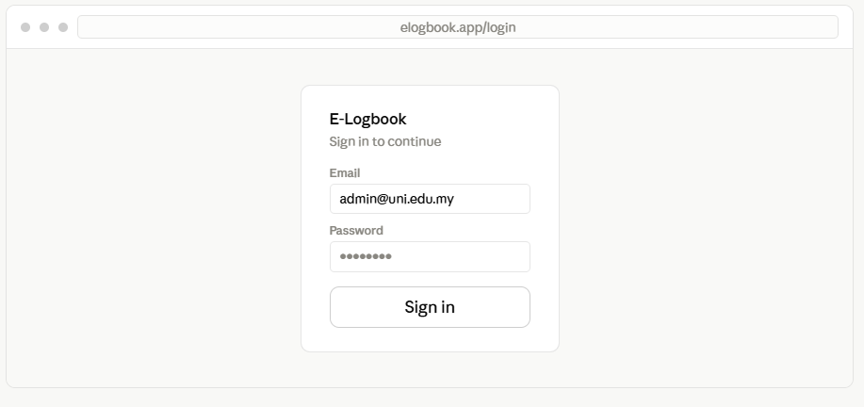
Figure 3.19. Webpage Login page
Entry point for admins and supervisors. Users enter their registered email and password. Laravel Sanctum verifies credentials and redirects each role to the appropriate dashboard view.
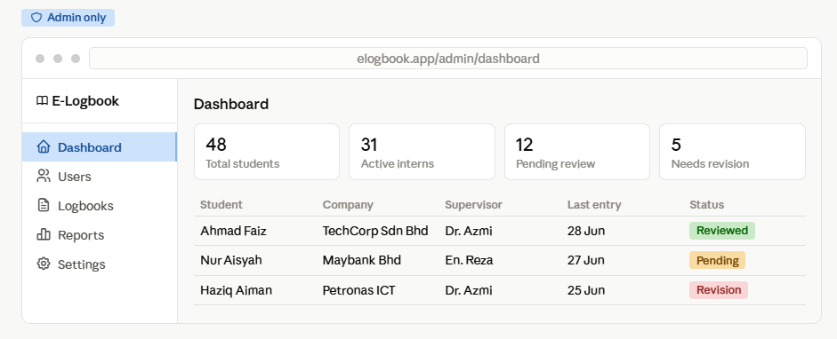
Figure 3.20. Admin Dashboard
This page provides administrators with an overview of the system, including internship statistics, user information, and pending logbook submissions. It also offers quick access to user management and report generation features.
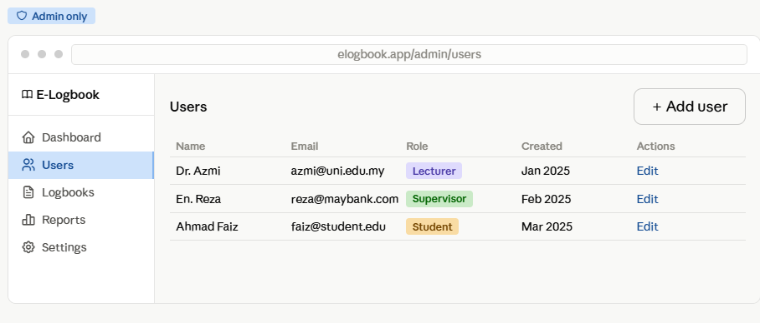
Figure 3.21. Admin User Management
Administrators have the ability to manage all users' accounts on this page, from the students to the lecturers and company supervisors. They have the ability to create, update, delete users' accounts and assign roles to them.
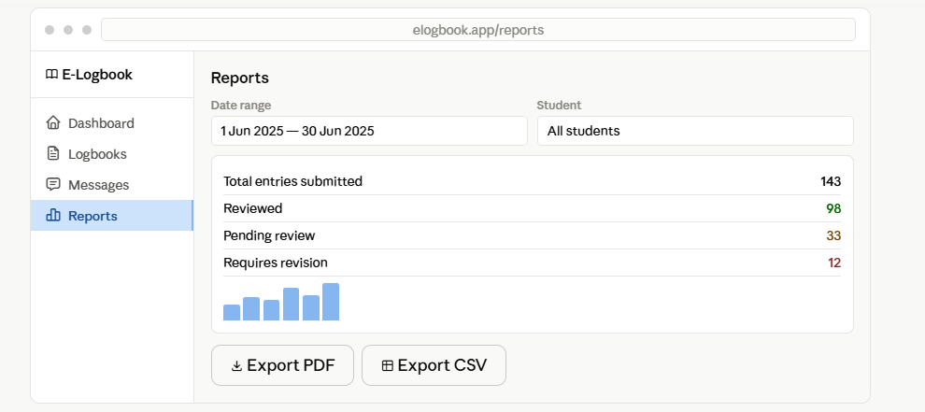
Figure 3.22. Generate and Download Reports
Admins can generate system-wide reports across all students. Lecturers and supervisors generate reports scoped to their own assigned students only.
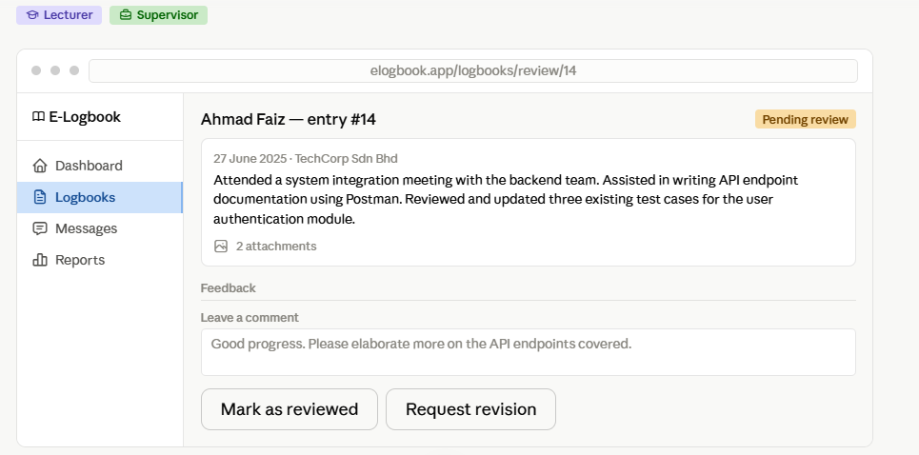
Figure 3.23. Logbook Review
View student entries and give feedback. The lecturers and company supervisors get to see all of their assigned student logbook entries in great detail. They can choose to either review, request revision, or give feedback on the entry.

Phase 3: Implementation
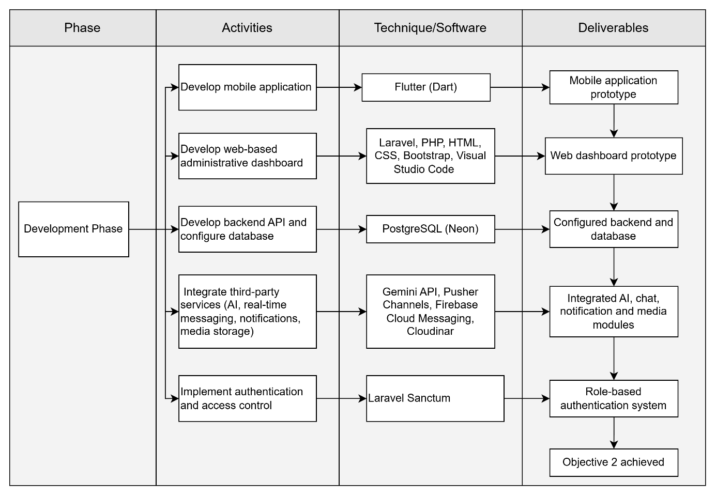
Figure 3.24 Implementation Phase
The Implementation phase will involve translating the system design produced in Phase 2 into a functional prototype. Development will follow the sequence of activities illustrated in Figure 3.24, beginning with the development of the mobile application and web-based administrative dashboard, followed by the implementation of the backend API and database, integration of third-party services, and finally the implementation of authentication and access control. Each component will be developed using the technologies justified in Section 2.4, resulting in a fully integrated internship logbook management system.

Mobile Application Development
This mobile application will be developed using the Flutter software technology together with the Dart programming language. This application is the main interface that will be used by students to keep track of their logbooks, communication with supervisors, get notifications, and use AI-based writing tools. Lecturers and company supervisors can also make use of this mobile application when reviewing logbooks and giving feedback to students without the use of a desktop computer.

Web-Based Administrative Dashboard Development
The dashboard that is accessible through the Web will be created using Laravel, PHP, HTML, CSS, Bootstrap, and Visual Studio Code. This dashboard will enable the administrators to manage the systems, including user management, system monitoring, and reporting. Also, lecturers and company supervisors will use this dashboard to assess the submission of logbooks, give comments on it, and create reports of the assigned students. The development process is expected to result in a working web dashboard prototype.

Backend API and Database Development
For building the backend API, the Laravel framework will be utilized, and PostgreSQL running on Neon will be employed as the database for the system. The Laravel Eloquent ORM will be used for handling communication between the database and the application. The backend will offer RESTful API endpoints for user authentication, logbook operations, reporting, and other functionalities of the system, while the database will store user credentials, logbooks, feedback, notifications, and other system data.

Third-Party Service Integration
Integration of some other third-party systems will be performed to augment the system's capabilities. The Gemini API will be integrated using the Laravel backend to offer assistance with writing suggestions that include both text only and text image requests using AI support. Pusher Channels will be integrated using Laravel Broadcasting and Flutter to allow real time messaging between students and supervisors. Firebase Cloud Messaging will be used to send push notifications for reminders, feedback and chat messages, whereas Cloudinary will be integrated to save logbook images uploaded by users and to retrieve them back using CDNs via their URLs.

Authentication and Access Control Implementation
Role-based authentication will be achieved by using Laravel Sanctum for token-based authentication in combination with the Spatie Laravel Permission package. After logging in, if the user's credentials are authenticated by the backend, the backend will generate a personal access token that will be securely stored using the package in the Flutter application. The access permissions will depend on the user's role. The students will have access to the application only via the mobile app, whereas the lecturers and company supervisors will have access to the mobile app and the web dashboard, but the administrator will have access only to the web dashboard.

Phase 4: Testing
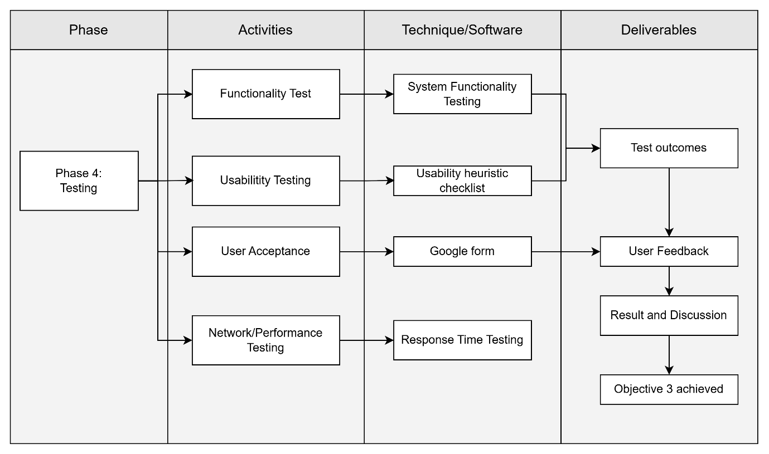
Figure 3.25 Testing Phase
As illustrated in Figure 3.25, in the Testing stage, it will be ensured that each module of the prototype works correctly and provides an adequate user experience through four forms of testing including functional, usability, user acceptance testing (UAT) and network performance testing. In functional testing, the technique of black box testing will be applied where the system will be tested on the basis of its input-output behavior without looking into the source code of the system. It is believed that this technique is most appropriate to verify each feature's correctness from users' point of view.
Tests would be designed that would focus on the primary functionality of each module designed for the application in the system design phase. In this regard, the tests will be recorded along with the modules being tested, the testing process involved, and the output desired. For instance, the authentication module will be tested using valid and invalid login attempts to check for proper access control, the logbook module through the addition of new entries in the system to ensure the information is stored and displayed correctly, the AI-based writing tool through verifying the generation of recommendations in a reasonable time frame, the chat module by ensuring the transmission of the message to the other user in real time, the notification module by testing the receiving of messages when the users are offline, and the image documentation process through the upload of supportive images.
In addition to the functional correctness test cases, usability tests will be carried out through observation of representative users in each of the four roles: student, lecturer, company supervisor, and administrator, as they perform tasks on the mobile application and web dashboard, in order to detect any possible problems with the user interface or navigation. The user acceptance test will be done through actual usage of the system by the students and the supervisors and will provide feedback on whether the system serves the purpose of managing internship logbooks, in line with Objective 3. The performance of the system will also be tested based on its behavior in various network environments, due to the dependence of the system on external services such as Gemini API, Pusher Channels, Firebase Cloud Messaging, and Cloudinary, all of which need a good network connection to work effectively.
The test cases that result in failure will be recorded together with the cause of the problem, and the module revised and retested until the expected output is obtained. This will continue until all the requirements established during the requirement analysis are tested successfully.

Phase 5: Deployment and Documentation
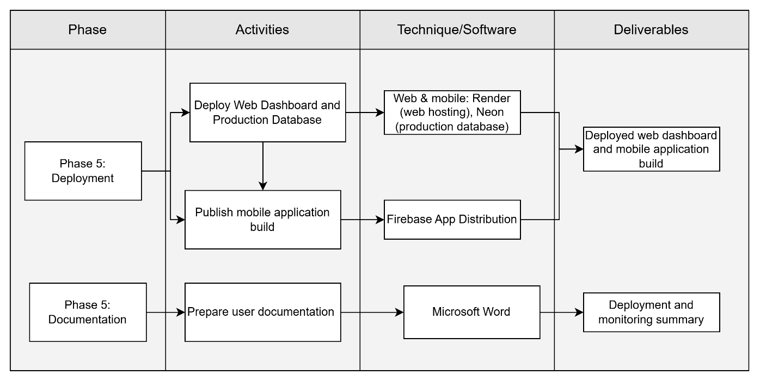
Figure 3.26 Deployment and Documentation Phase
As illustrated in Figure 3.26, the Deployment phase concentrates on the deployment of the completed Internship E-Logbook System to make it operational. At the Deployment phase, the Laravel web dashboard will be deployed in Render, which is a cloud hosting service provider, while the production PostgreSQL database hosted at Neon will be properly set up to provide a secure and reliable storage for the application data. The Flutter mobile application will be developed as an Android APK package and delivered to the project supervisor and testers by means of Firebase App Distribution, thus being installed directly on the device without publishing to the Google Play Store. Also, integrated cloud services like FCM (Firebase Cloud Messaging) will be set up for push notifications functionality in the production environment. Upon completion of the Deployment phase, the basic performance of the system will be tested using the built-in dashboard at Render in order to assure the proper working of all key features such as authentication, logbook, AI-based writing, messaging, notifications, and images upload functionalities. Completion of the Deployment phase will result in the deployment of the web dashboard and mobile application build, as well as in the deployment and monitoring summary report.
The Documentation stage entails preparing all required documents to help users and facilitate any future system maintenance. The preparation of user manuals and other training documents will be done through Microsoft Word so that the students, lecturers, company supervisors, and administration can use the system easily. Some of the things to be covered include the process of logging in, managing the logbook, messaging, notifications, reports creation, and managing one’s account on the system. Feedback from users will also be sought during the first use of the system so that there can be improvements for the future. The deliverable for this stage is a comprehensive user manual.

Summary of the Chapter
This chapter illustrates the process followed to develop the proposed Internship E-Logbook System using the Waterfall Model. This chapter discusses the various phases involved in software development which include Requirement Analysis, System Design, Implementation, Testing, and Deployment and Documentation as well as the respective processes involved in each phase. In the Requirement Analysis phase, system requirements will be derived from the background study and literature review. System Design phase will convert the identified system requirements to system architecture, flow charts, use case diagram, entity relationship diagram, and user interface storyboard. Implementation phase will involve development of the Flutter mobile application, Laravel web dashboard and PostgreSQL database as well as integration of cloud services such as Gemini API, Pusher Channels, Firebase Cloud Messaging, Cloudinary, and Laravel Sanctum. Testing phase will involve verification that the system developed satisfies its functional and non-functional requirements through functional testing, usability testing, user acceptance testing, and network performance testing.
Every stage of the Waterfall Methodology corresponds directly with the objectives defined in section 1.3. The Requirement Analysis stage (Stage 1) is achieved through objective 1, in which the problems and constraints of manual logbooks management will be recognized. System Design and Implementation stages (Stages 2 and 3) are accomplished through objective 2, in which the development of the system with the use of artificial intelligence on mobile devices will be carried out. Finally, the Testing stage (Stage 4) is achieved through objective 3, in which the efficiency of the developed system will be assessed. Thus, the methodology gives a framework that ensures the achievement of project objectives, laying the basis for the implementation and assessment results to be described in the next chapter.

REFERENCES
Ahmed, M. O., Neal, A. O., & Chizoba, C. (2026). A digital solution for student internship: Tracking and enhancing student’s experience. Asian Journal of Basic Science & Research, 8(1), 23–36. https://doi.org/10.38177/ajbsr.2026.8103
Akhtar, A. (2023). Popularity ranking of database management systems. arXiv. https://arxiv.org/abs/2301.00847
Ambara, M. P., Gunawan, I. M. A. O., & Wijaya, I. W. R. (2024). Agile-based field internship information system for academic administration digitalization. Jurnal Teknologi Informasi dan Pendidikan, 19(1), 1–10. https://doi.org/10.24036/jtip.v19i1.1069
Bawica, I. M. (2021). The university internship program and its effects on students’ employability readiness. International Journal of Academe and Industry Research, 2(3), 90–106. https://doi.org/10.53378/348731
Castro, E. G. M. (2024). Mobile-based student internship monitoring system using progress tracking algorithm. International Research Journal on Advanced Science Hub, 6(8), 204–209. https://doi.org/10.47392/IRJASH.2024.029
Dewi, F. K., & Hanifah, R. N. (2024). Web-based student internship monitoring information system (Case study: SMK Ma’arif NU 2 Boyolali). IC-ITECHS, 5(1), 943–956. https://doi.org/10.32664/ic-itechs.v5i1.1705
Hartono, R. (2024). Website-based information system for internship attendance and daily activity recording. Journal of Information Systems and Business Technology, 3(1), 1–10. https://journal.jci.co.id/jisbt/article/view/302
Haw, S.-C., Amin, A., Naveen, P., & Ng, K.-W. (2022). Performance evaluation of XML dynamic labeling schemes on relational database. International Journal of Technology, 13(5), 1055–1063. https://doi.org/10.14716/ijtech.v13i5.5871
Joiner, D., Clement, M., Chan, S. T., & Pereira, K. (2022). DW vs OLTP performance optimization in the cloud on PostgreSQL: A case study. IEEE RASSE 2022. https://doi.org/10.1109/RASSE54974.2022.9989603
Kapoh, H., Melo, O. E., & Kimbal, A. A. (2024). Digitalization of the internship management system to support independent learning campus program. International Journal of Computer Applications, 186(1), 16–21. https://doi.org/10.5120/ijca2024923335
Kishore, K., Khare, S., Uniyal, V., & Verma, S. (2022). Performance and stability comparison of React and Flutter: Cross-platform application development. IEEE ICCR 2022. https://doi.org/10.1109/ICCR56254.2022.9996039
Lang, G., Triantoro, T., & Sharp, J. H. (2024). Large language models as AI-powered educational assistants: Comparing GPT-4 and Gemini for writing teaching cases. Journal of Information Systems Education, 35(3), 390–407. https://doi.org/10.62273/YCIJ6454
Li, H., Wang, X., Feng, Y., Qi, Y., & Tian, J. (2024). Driving intelligent IoT monitoring and control through cloud computing and machine learning. arXiv. https://doi.org/10.48550/arXiv.2403.18100
Mah, D.-K., & Groß, N. (2024). Artificial intelligence in higher education: Exploring faculty use, self-efficacy, distinct profiles, and professional development needs. International Journal of Educational Technology in Higher Education, 21, Article 58. https://doi.org/10.1186/s41239-024-00490-1
Mustapa, N. R. N., & Mustapa, S. H. N. (2023). Design and development of mobile application for academic reminder system. Journal of Computing Research and Innovation (JCRINN), 5(4). https://doi.org/10.24191/jcrinn.v5i4.167
Okoye, K. R., & Edokpolor, J. E. (2021). Effect of industrial work experience in developing Technical and Vocational Education undergraduates’ employability skills. Asian Journal of Assessment in Teaching and Learning, 11(1), 1–12. https://doi.org/10.37134/ajatel.vol11.1.1.2021
Osowski, C. P., Mugisha, R., Bälter, K., & Bälter, O. (2023). Effect of personalized email-based reminders on participants' timeliness in an online education program: Randomized controlled trial. JMIR Formative Research, 7, e43977. https://doi.org/10.2196/43977
Pari-Ayala, L. A., & Ramos, H. (2025). Hybrid Web Architecture with AI and Mobile Notifications to Optimize Incident Management in the Public Sector. Preprints. https://doi.org/10.20944/preprints202512.1056.v1
Peláez-Sánchez, I. C., Velarde-Camaqui, D., & Glasserman-Morales, L. D. (2024). The impact of large language models on higher education: Exploring the connection between AI and Education 4.0. Frontiers in Education, 9. https://doi.org/10.3389/feduc.2024.1392091
Petcharat, W., & Sutthirak, T. (2024). Enhancing the efficiency of internship management through the implementation of progressive web app. International Journal of Interactive Mobile Technologies, 18(22), 19–34. https://doi.org/10.3991/ijim.v18i22.49227
Purba, S. (2026). Implementation of role-based access control (RBAC) in a drug stock management information system. Sistemasi: Jurnal Sistem Informasi, 15(1). https://sistemasi.ftik.unisi.ac.id/index.php/stmsi/article/view/5958
Qabajeh, M. M., Jaber, D. E.-A., & Mashni, T. K. (2025). Web application for internship management using Laravel framework. ACIT 2025. https://doi.org/10.1109/ACIT68900.2025.11510564
Seman, K., Suhaimi, S. A., & Nor, A. M. (2022). Digital Internship Logbook (DIL) for business students in UNITEN. International Journal of Business Management, 5(1). https://journal.uniten.edu.my/index.php/ijbm/article/view/275
Setiaji, P., Adiyono, S., Prayogo, A., & Kurniasari, N. (2025). Developing a cloud-native internship management platform: Enhanced efficiency and integration through object-oriented architecture. Journal of Information Systems and Informatics, 7(1), 631–648. https://doi.org/10.51519/journalisi.v7i1.1036
Sharma, S., Khare, S., Uniyal, V., & Verma, S. (2022). Hybrid development in Flutter and its widgets. IEEE ICCR 2022. https://doi.org/10.1109/ICCR56254.2022.9995973
Sidik, R., Husnaini, A. N., Kholil, M., et al. (2024). Development of a daily monitoring information system for industrial internship. INTI Journal (Nusa Mandiri), 19(2), 1–10. https://doi.org/10.33480/inti.v19i2.6406
Surahmat, A., & Darmawan, R. (2024). Application of SDLC method and Laravel framework in developing web-based information system. Scientific Journal of Information System, 2(1), 20–25. https://doi.org/10.70429/SJIS.V2I1.101
Thammastitkul, A. (2023). Cloud-based computing adoption in internship management system for university education. Naresuan University Journal: Science and Technology, 31(1), 58–73. https://doi.org/10.14456/nujst.2023.7
Wan Abdul Rahman, W. F., Mohamad Bustamam, M. S., & Putra, Y. H. (2024). The development of an integrated cloud-based system to enhance internship management. Journal of ICT in Education, 11(2), 92–110. https://doi.org/10.37134/jictie.vol11.2.8.2024
Weber, K., Cai, T., & Elliston, Z. (2023). I can see clearly now: Using ePortfolios to support reflection and engaged learning in a summer internship program. International Journal of ePortfolio, 13(1), 55–67. https://files.eric.ed.gov/fulltext/EJ1407265.pdf
Wibowo, S., Faizah, N. M., & Nurcahyo, W. (2024). Android-based industrial internship management system using Flutter framework. Journal Mobile Technologies (JMT), 2(1), 1–9. https://doi.org/10.59431/jms.v2i1.292

